4th Sunday after Epiphany (Year A)

__________________________________________________________________________________________

Matthew 5:1-12

When Jesus saw the crowds, he went up the mountain; and after he sat down, his disciples came to him. Then he began to speak, and taught them, saying:
‘Blessed are the poor in spirit, for theirs is the kingdom of heaven.
‘Blessed are those who mourn, for they will be comforted.
‘Blessed are the meek, for they will inherit the earth.
‘Blessed are those who hunger and thirst for righteousness, for they will be filled.
‘Blessed are the merciful, for they will receive mercy.
‘Blessed are the pure in heart, for they will see God.
‘Blessed are the peacemakers, for they will be called children of God.
‘Blessed are those who are persecuted for righteousness’ sake, for theirs is the kingdom of heaven.
‘Blessed are you when people revile you and persecute you and utter all kinds of evil against you falsely on my account. Rejoice and be glad, for your reward is great in heaven, for in the same way they persecuted the prophets who were before you.
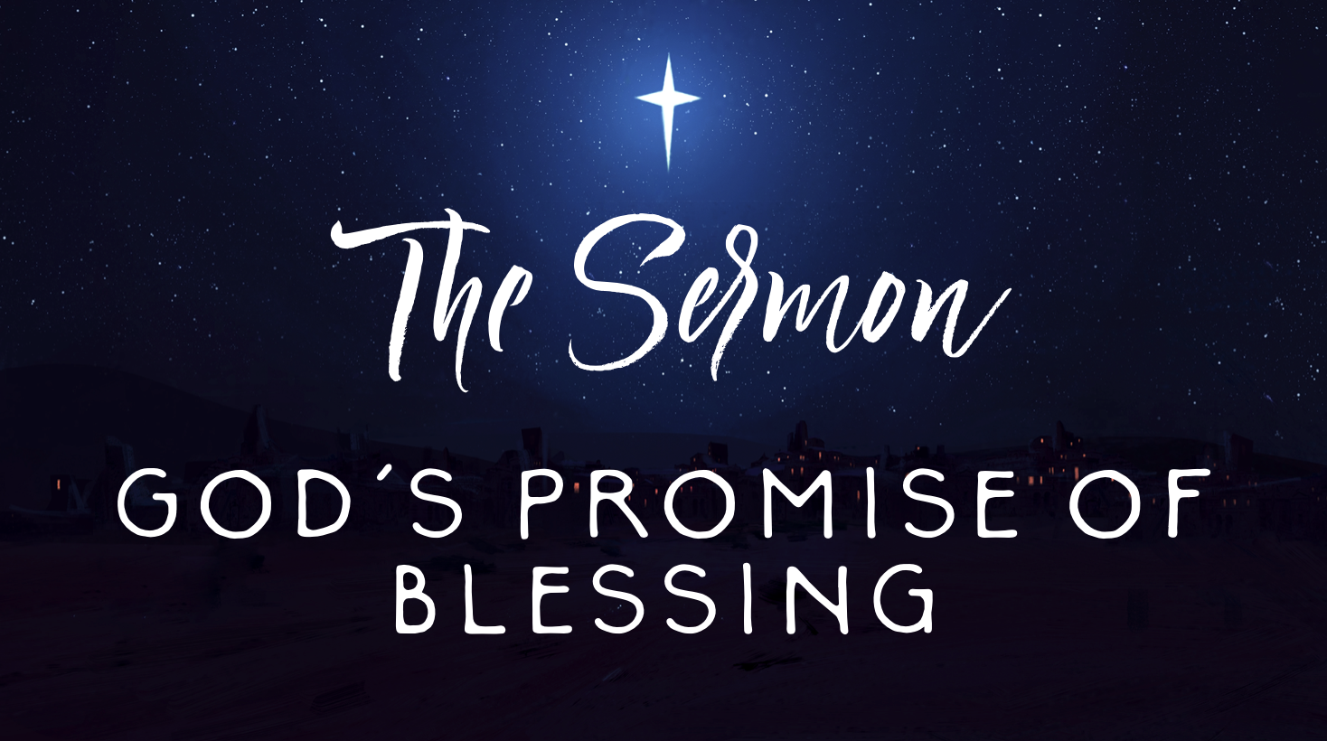
__________________________________________________________________________________________
What we call one another matters. The language we use to define a human being makes all the difference in the world. David Lose, a Lutheran pastor and preacher, said the following in a blog post I stumbled across this week: “Children…become what they are named. Call a child bad long enough, and he or she will believe you and act bad. Call a child (or teen or adult for that matter) worthless or unlovable or shameful, and eventually he or she….will live into the name [they’ve] been assigned. In the same way, call us good or useful, dependable, helpful, or worthwhile, and we will grow into that identity and behavior as well.”
I think Jesus knew this to be true. After gathering Peter, Andrew, James, and John, by the lakeside in last week’s passage, Jesus finds himself in the company of a crowd of people who had been called many names: poor, broke, worthless, dirty, impure, leprous, sinful, you take your pick. But Jesus assigns them a different name: blessed.
That’s a word that get’s thrown around a lot and, because of that, it’s important to make sure we’re all on the same page about what we’re talking about. A few years ago, #blessed trended on twitter for quite awhile with everyone posting about what was going great in their lives.
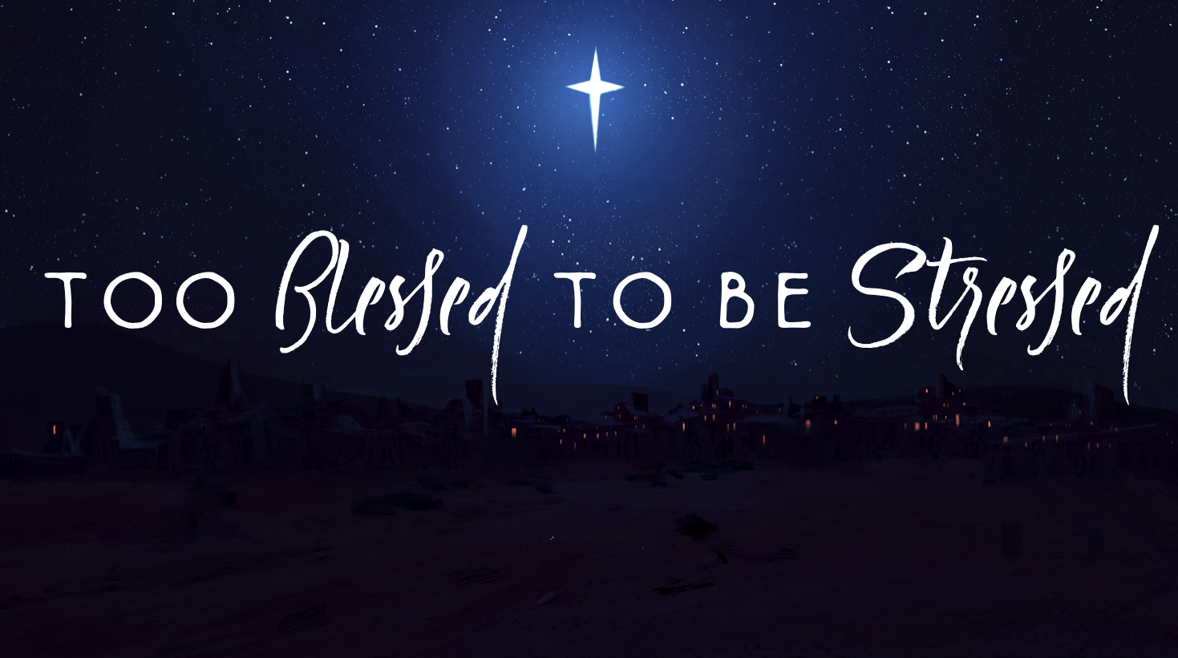
I’m sure y’all have seen those t-shirts with the catchy phrase, “Too Blessed To Be Stressed.” A quick search of my Facebook feed of the word “blessed” revealed a host of pictures of my friends displaying posts about everything from enjoying vacation, to drinking a cup of coffee, to getting a new job, or celebrating some sort of milestone that has brought them happiness and joy.
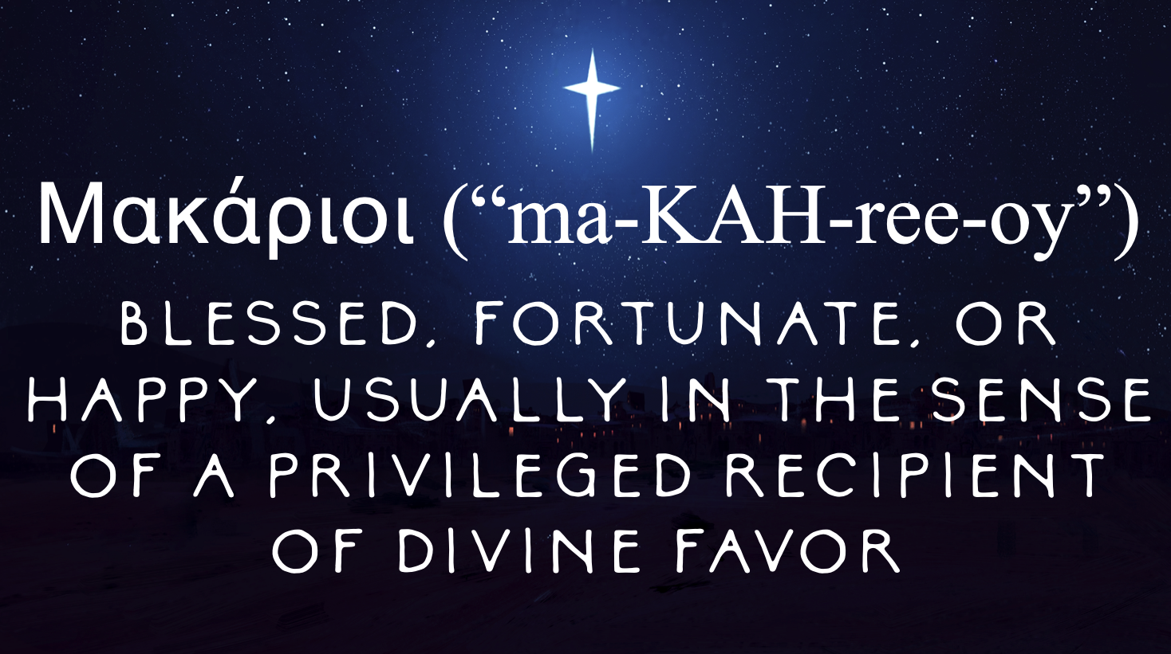
“Blessed” is one of the most popular faith-y terms that a quick search on Etsy brings up countless home decor options for shirts, pillows, paintings, necklaces, and bumper stickers. Forgive me if this sounds cynical but “Blessed” is just one of those words where the preacher inside of me wonders if we’ve overused it in common parlance to the point that it is itself rendered meaningless.
So what does it mean? Well, the Greek word is μακαριοι (“ma-KAH-ree-oy”) and it means “blessed, fortunate, or happy, usually in the sense of a privileged recipient of divine favor.” In this sense, “blessed” is so much deeper than “happy” or general contentment. Blessed is deeper than that feeling when the first sip of coffee touches your tongue. Blessed is deeper than your elation when your team wins the super bowl. Blessed is deeper than feeling lucky, or fortunate, or upbeat and rosy.
We live in a culture where we’re often tempted to display - and perhaps sometimes even fabricate - an image of ourselves that glosses over the messiness of our lives, the challenges we face, the strained relationships that we’re a part of, the wrinkles in our skin or the parts of our bodies that we wish were different. It’s all too easy to let the Instagram filter infiltrate our lives to the point that we unknowingly treat blessing as a competition with our neighbors; we try to “out-bless” one another to establish that we’ve accomplished the norms of “success” our society places before us. And, in doing so, we’ve set some painful expectations that set us up for failure and broken hearts.
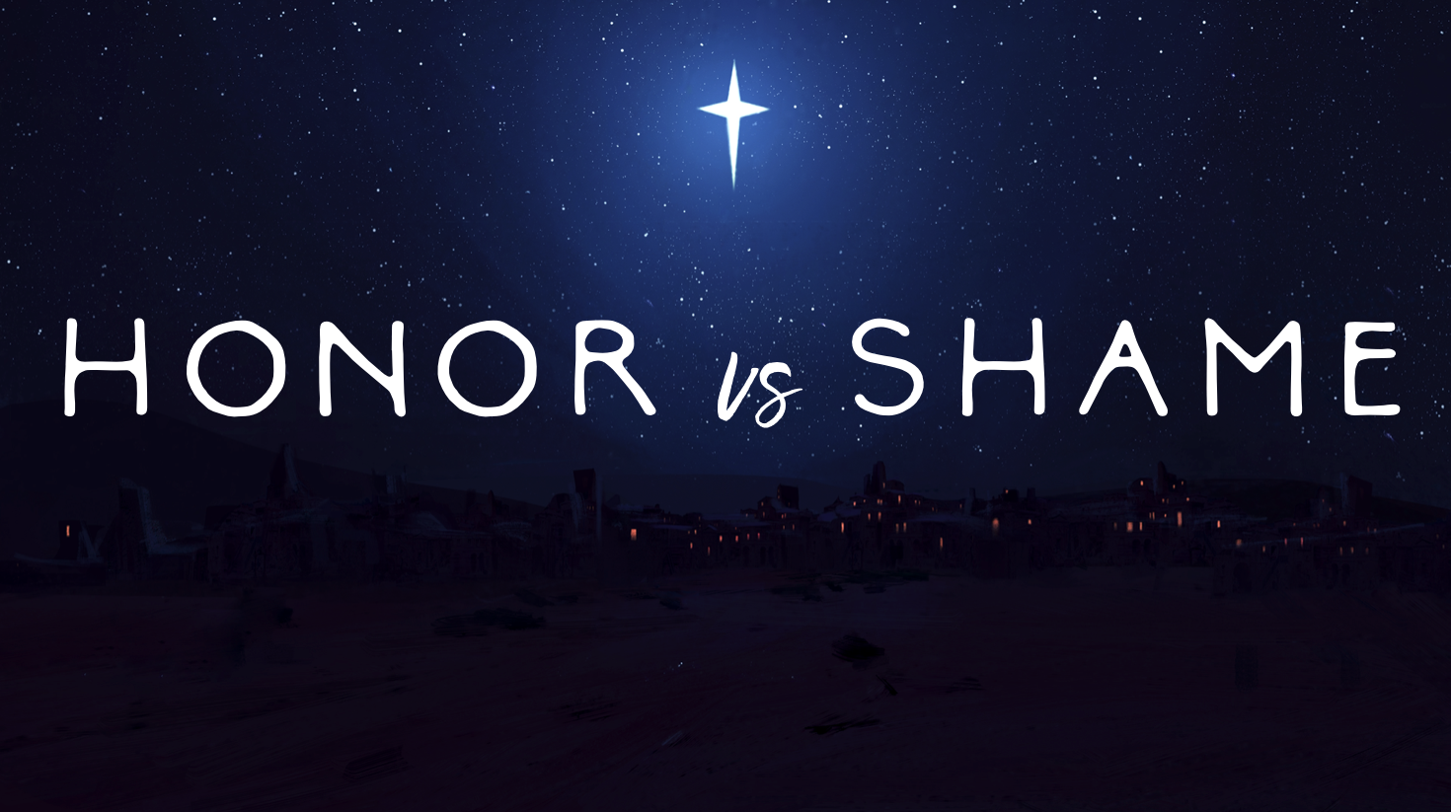
But to be “blessed” in terms of the Beatitudes is about completion or restoration. It is to receive divine favor through the promise that everything within you that has been taken away will be restored; that all that is within you that feels broken, hopeless, bruised, and battered does not define you in God’s eyes. That’s what blessedness means in today’s passage.
And to understand why that restoration is so necessary, you have to understand the dynamics of the honor-shame culture of Jesus’ time. In those days, in ways both different and similar to our own culture, honor was rewarded and shame was punished. If you were wealthy, you had honor and, therefore, privilege. You got the best seat at the table. You had political influence. You wore nice clothes and were able to go wherever you wanted. On the other hand, if you were poor, or sick, or disabled, you had shame and, therefore, dishonor. There was no seat for you at the table. Zero political influence. You wore shabby clothes and were limited in your choices with virtually zero chance of upward social mobility. And what’s more, shame didn’t just reflect poorly on you in the eyes of the society you lived in, it affected your whole family. There’s a reason so many of the people Jesus ministered to lived lives of solitude: because they had been disowned by their family because their shame became their family’s shame and negatively affected them, too.
And together, these kinds of people, these shamed persons, gathered before Jesus and he had the audacity to call them blessed. The reason I brought up just how much we tend to throw that word around is that I wonder if we sometimes forget the subversiveness of Jesus’ use of that specific word to define the people in the crowd. You see, the honor/shame dynamic of first century Palestine was a zero-sum game; in order for one person to have honor, another had to have shame. It was a cruel rat race where in order for one person to win, another had to lose. So when Jesus turns to the poor, the abused, the forgotten, and the diseased, and calls them favored in the eyes of God, what he is in effect also saying is that oppressive systems, and those that perpetuate them, are disfavored in the eyes of God. Now we begin to see the truly revolutionary nature of the Beatitudes. They’re more than just blessings, their a direct challenge to the status quo. It’s a non-violent protest to the circumstances that cause the sorrowful to mourn, the meek to be trampled upon, and those who hunger and thirst for righteousness to be treated with disdain at best and persecution at worst.
Now that we’ve established the context of how the Beatitudes would have been received by the ears of first century Palestinians, our next task is asking ourselves the following question: what is a historically appropriate connection from the ancient world to our modern world regarding this text?

We’ve already unpacked the word “blessed” so let’s look briefly at the words “poor” and “spirit”
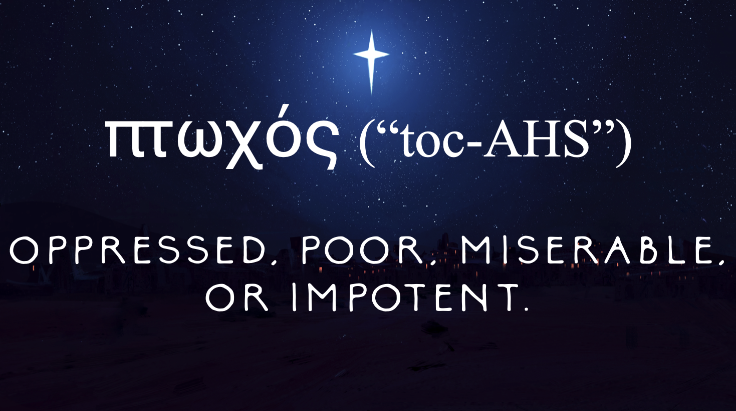
To answer that question, let’s take a look at the first Beatitude: “Blessed are the poor in spirit.” and hopefully we’ll find a connection to our current world.

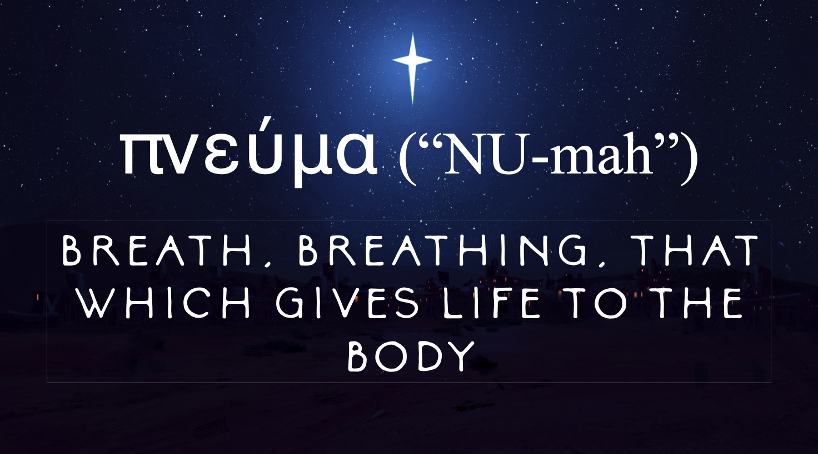
The word “poor” is the Greek word πτωχός (“ptocos”) and means oppressed, poor, miserable, or impotent.
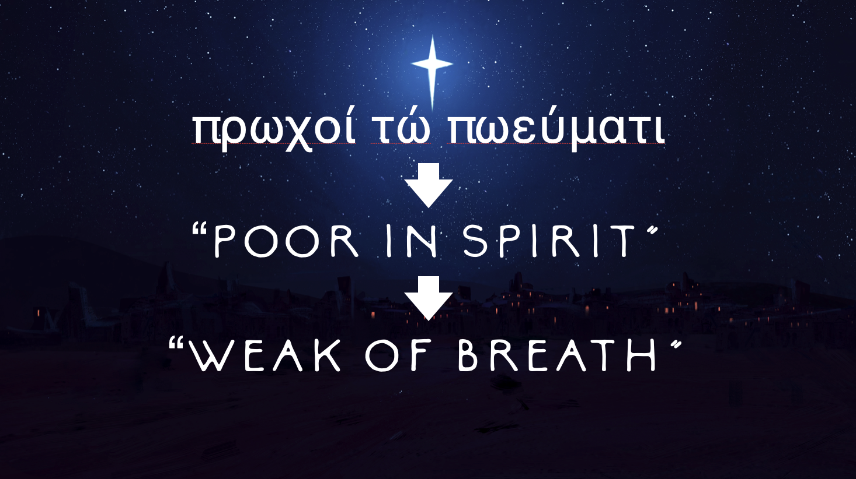
The word “spirit” is the Greek word πνεύμα (“pneuma”) and is usually translated in English as “spirit” but it doesn’t mean “spirit” in the way that you and I often think of. It also means breath or breathing. It is literally “that which gives life to the body.” When we read the Beatitudes and hear the phrase “poor in spirit,” we might think of someone who is depressed, or sad, or downtrodden (and that might be true!). But it’s much more physical than that.
One could faithfully translate “poor in spirit” as “weak of breath.” It is someone struggling to breath, someone whose body is failing, someone whose circumstances threaten that which gives their body life.
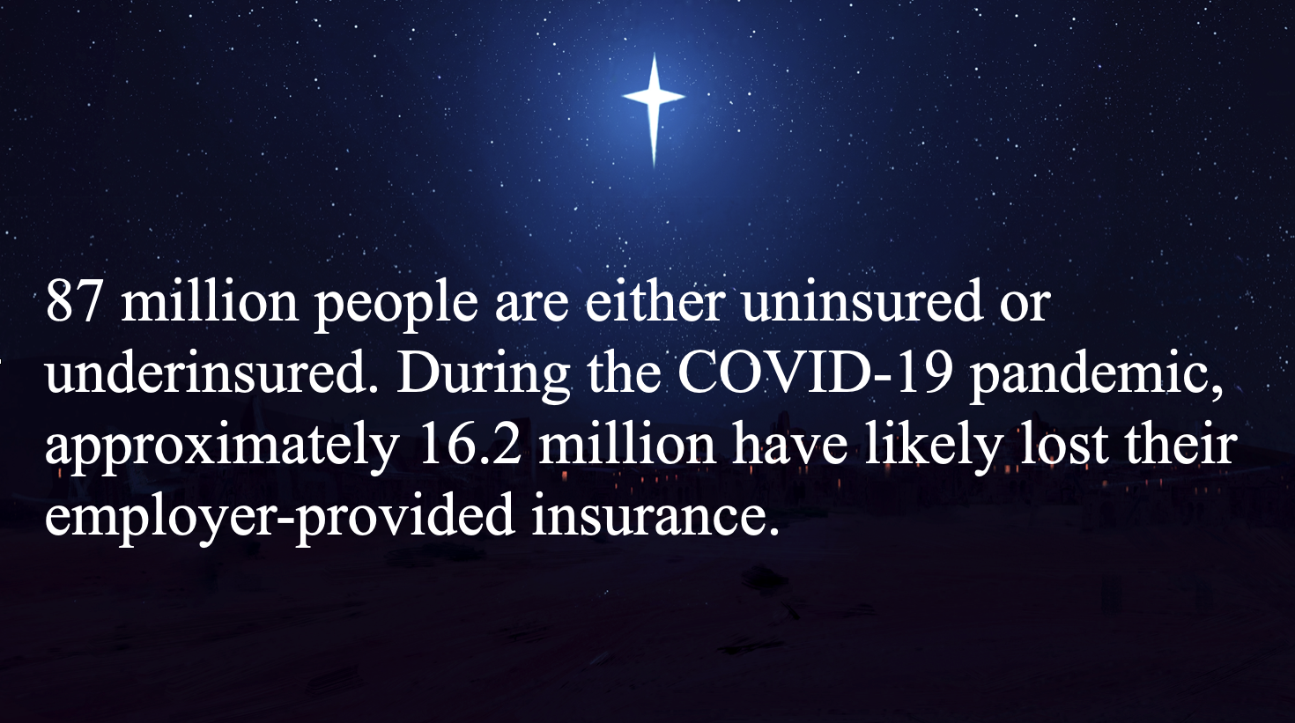
Therefore, when I hear Jesus saying “blessed are the weak of breath,” I think about the problem of affordable healthcare in our neighborhood.

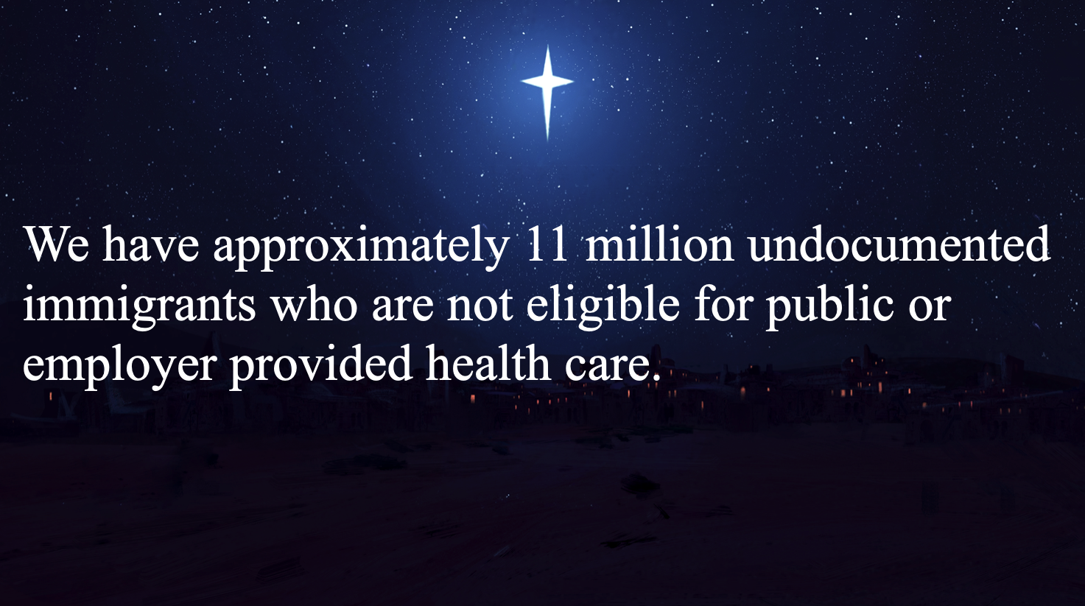
Currently, 87 million people in this country are either uninsured or underinsured. During COVID-19, approximately 16.2 million more people lost their employer-provided insurance.
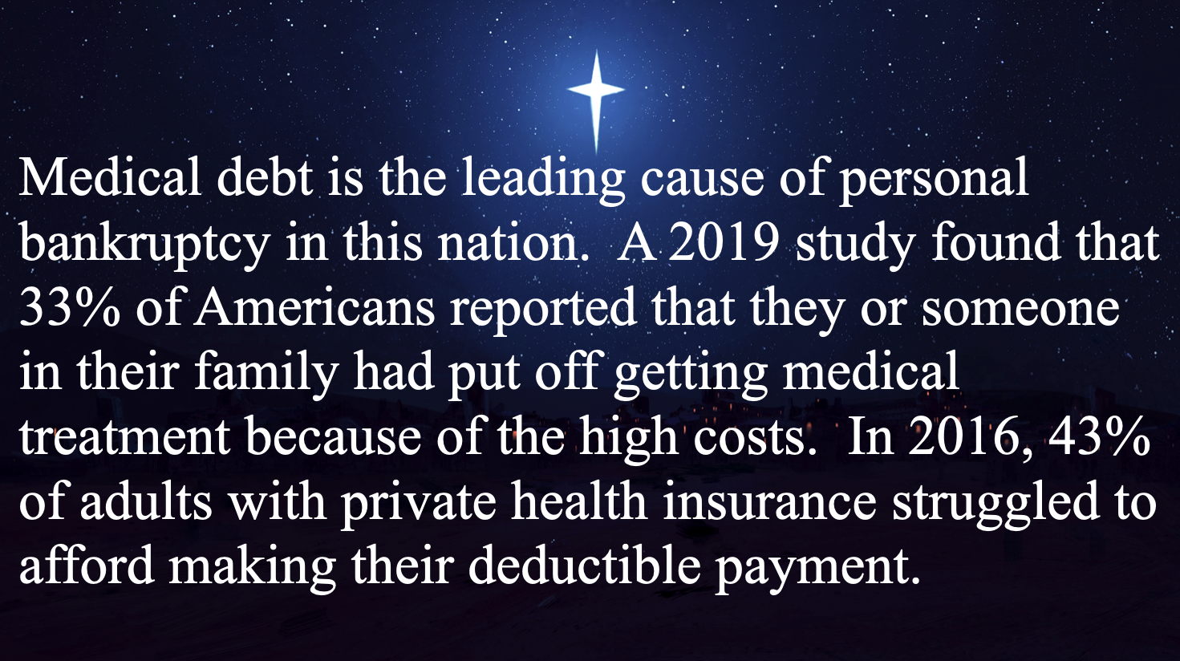
We have approximately 11 million undocumented immigrants who are not eligible for public or employer provided health care.
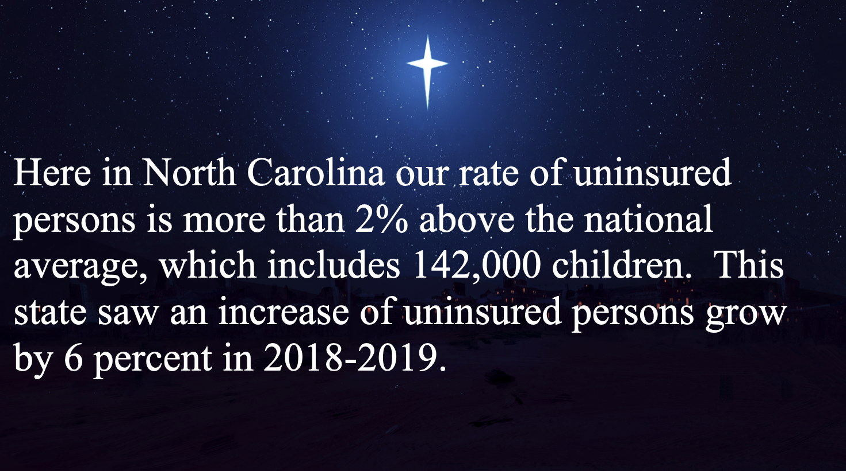
And medical debt is the leading cause of personal bankruptcy in this nation. A 2019 study found that 33% of Americans reported that they or someone in their family had put off getting medical treatment because of the high costs. In 2016, 43% of adults with private health insurance struggled to afford making their deductible payment. I was talking with Bill Hickling yesterday about this sermon and he told me that 56% of Americans can’t afford a $1,000 emergency medical cost.
Here in North Carolina our rate of uninsured persons is more than 2% above the national average, which includes 142,000 children. This state saw an increase of uninsured persons grow by 6 percent in 2018-2019.
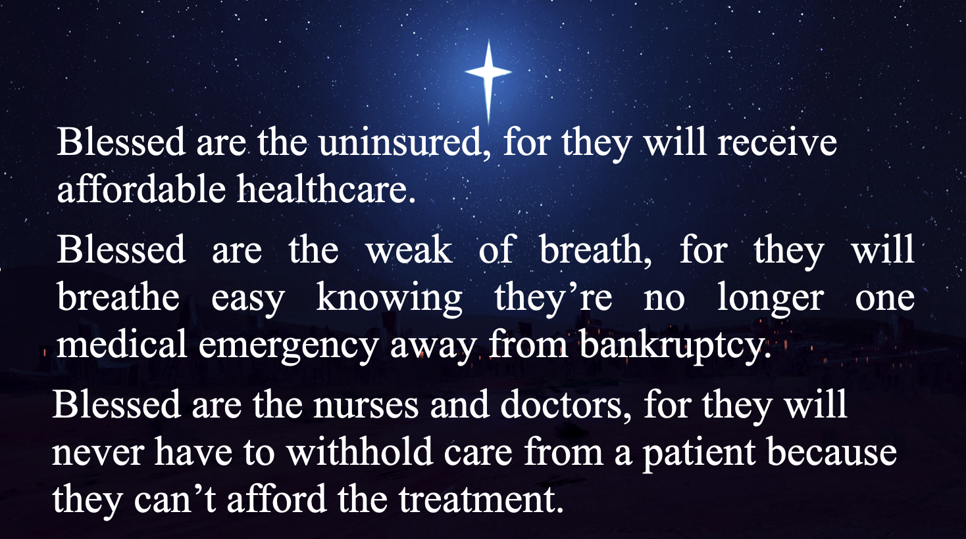
Given this data, we could faithfully add a few more Beatitudes in the spirit of those Jesus gives us in today’s passage:

Blessed are the uninsured, for they will receive affordable healthcare.
Blessed are the weak of breath, for they will breathe easy knowing they’re no longer one medical emergency away from bankruptcy.
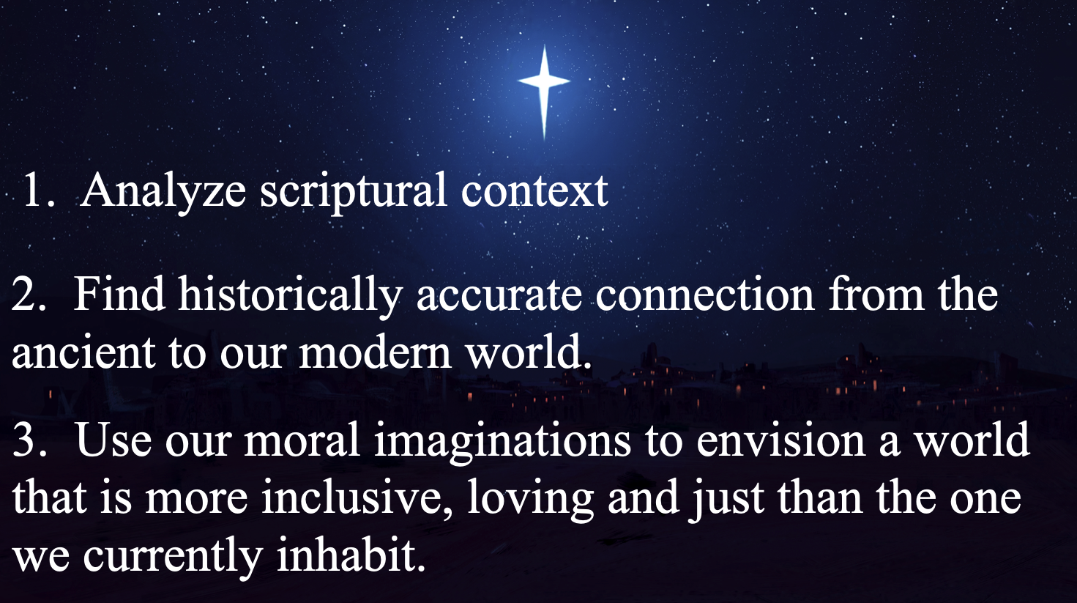
Blessed are the nurses and doctors, for they will never have to withhold care from a patient because they can’t afford the treatment.
Now, just so y’all know, in this sermon I’m using a three-step technique that I’ve been instructed to use as part of a preaching class I’m taking this semester. The first step is to analyze the context of the world in which the scripture was written. We did this by exploring the honor/shame culture in which the Beatitudes were originally presented. The second step is to find a historically appropriate connection from the ancient world to our modern world. We did this by reading the Beatitudes through the lens of this nation’s healthcare crisis. Our third and final step is this: “we use our moral imaginations to envision a world that is more inclusive, loving, and just than the one we currently inhabit.”
What does it mean to use our moral imagination? It means to look beyond the current circumstances of our world, beyond its brokenness and barrenness, to see the Kingdom of Heaven that Jesus ushers in. Moral imagination is to stubbornly refuse that the way things are are the way things have to be. Moral imagination is to have the audacity of the poet of Isaiah to envision a day when God will wipe the tear from every eye and swords will be melted down and made into plowshares. That’s moral imagination. The Beatitudes are nothing more or less that Jesus blessing his moral imagination upon those whose very lives depend on that Kingdom coming to fruition. Moral imagination pushes past those who think we’re foolish for the audacity of the promises Jesus makes to those who gathered to hear his message. Moral imagination is what compelled Dr. Martin Luther King, Jr. to write his Letter from Birmingham Jail that we will read in its entirety in this very room in a few hours.
So, how can we apply our moral imagination to the situation of the lack of affordable healthcare in this country?
We can imagine a world where healthcare is never a for-profit enterprise. And, by the way and for the record, Bill Hickling informed me yesterday that Cone healthcare is not a for-profit enterprise. In fact, in 2020 Cone Health provided more than $530 million in uncompensated care for those in our community who couldn’t afford it. I mentioned this to say pastorally that my critique of the healthcare system is not a blanket statement condemning any and all healthcare providers. It is, instead, to make a commentary, through the lens of the Gospel, of the wider systemic issues in the healthcare industry we have in this country.
And so, we keep on practicing our moral imagination. We can imagine a world where no mother has to chose between putting food on the table and buying her daughter’s insulin.
We can imagine a world where everyone has access to affordable mental health care!
We can imagine a world where affordable healthcare builds up the whole neighborhood, and no one lacks the care they need to support themselves and their families.
Is that world a pipe dream? Practitioners of moral imagination refuse to answer that question with any answer other than NO!
Now, you and I might have different opinions on how to go about that. We might even vote differently depending on our understanding of what the best solution is. But my hope, as a Christian community, is that we can agree that the Beatitudes require us to impart God’s blessing upon those who backs are bent with the weight of the world’s brokenness. I hope you and I can agree, no matter our political or theological differences, that it would be a beautiful thing to call someone not only blessed, but worthy. To say to the immigrant: you are no less a child of God than I, and therefore you are worthy of affordable healthcare. To say to the single mother working three part time jobs with no benefits to support her children; you are worthy of the same dignity as I am given by having access to affordable healthcare. To say to the elementary school student whose parents don’t know where the next meal is coming from because of their medical debt; you are worthy of the same care and respect as anyone else, and yours is the kingdom of heaven.
Wouldn’t that be a beautiful thing? That’s what God’s promise of blessing does to you: it stretches the limits of what we think is possible, to see beyond the broken and into the blessed realm of God’s kingdom.
We end this sermon in the same place we began: what we call one another matters. When we call the meek blessed, when we call the mourners blessed, the peacemakers blessed, the poor in spirit blessed: we are engaging in sacred work that builds up the neighborhood and sets us to ever more faithfully rejoice in the fact that ours is the kingdom of Heaven.
In the name of God the Creator, Redeemer, and Sustainer, may all of us, God’s children, say: Amen.

https://www.workingpreacher.org/dear-working-preacher/salt-light
https://www.poorpeoplescampaign.org/wp-content/uploads/2020/06/Health-Fact-Sheet-05-28-20.pdf
https://www.ncjustice.org/u-s-census-bureau-releases-data-on-health-insurance-coverage-in-n-c/
Walton, Jonathan L. “A Lens of Love: Reading the Bible in Its World for Our World” page 87.

