6th Sunday of Easter (Year A)

__________________________________________________________________________________________

Psalm 66:10-12

For you, O God, have tested us;
you have tried us as silver is tried.
You brought us into the net;
you laid burdens on our backs;
you let people ride over our heads;
we went through fire and through water;
yet you have brought us out to a spacious place.
__________________________________________________________________________________________
Not that I have much down time these days, but in one of these rare moments, I was flipping through the television and came across a reality television show called Wipeout.

It’s a current reboot of a television series first aired back when I was in college that features contestants competing by running through obstacles courses. These gauntlets are usually placed in the air above a shallow pool or mud pit for both the safety of the contestants and the amusement of television viewers. Because, let’s be frank with one another, it wouldn’t be funny if every run was successful. What makes the show funny is when people, well, wipe out.
Because who doesn’t laugh when watching someone do a face plant into a giant rubber ball or trip themselves up and find themselves flying, arms flailing, into a pit of mud.

It’s childish humor, of course; physical comedy that harkens back to the days of Charlie Chaplin. But there’s just something within us that laughs when others are running an obstacle course and wipeout.
The Germans, of course, have a well-known word to describe this phenomenon: schadenfreude, which literally means “harm-joy.” It’s “the experience of pleasure, joy, or self-satisfaction that comes from learning of or witnessing the troubles, failures, or humiliation of another.” And while television shows like Wipeout are relatively harmless vices that don’t bring any real harm to another, schadenfreude can express itself in ways that do hurt others.

Which is why our Ted Lasso declares his football team a “No Schadenfreude Zone.” He wants his teammates to focus on building one another up instead of tearing one another down or rejoicing when others screw up and trip up.
In that light, I couldn’t help but ask myself the following question as I pondered today’s text: if God does test us, as today texts - and others - insist, why does God test us and what meaning are we to find in it?
Because, at first glance, the idea of a God who puts us to the test can leave us with images of God not unlike some sort of heavenly “Willy Wonka” who brings us to his divine chocolate factory to see if we pass a gauntlet of ethical obstacles courses. But, all joking aside, if we take today’s text at face value that God does, in fact test us, it can raise some other questions, like:
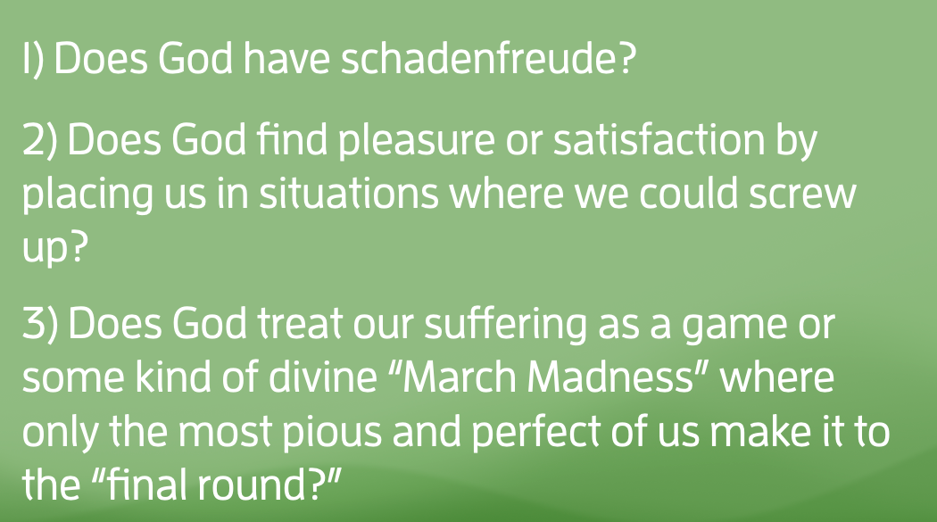
  - Does God have schadenfreude?
  - Does God find pleasure or satisfaction by placing us in situations where we could screw up?
  - Does God treat our suffering as a game or some kind of divine “March Madness” where only the most pious and perfect of us make it to the “final round?”
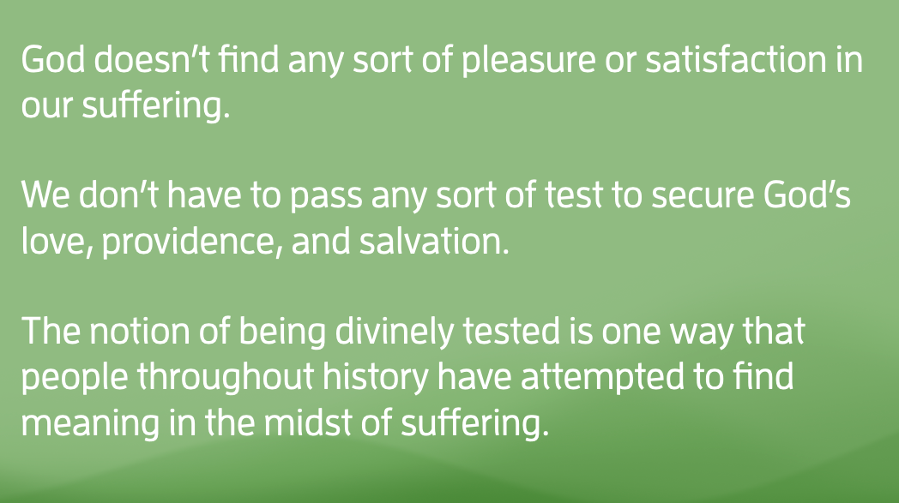
While I don’t know if there are easy, simple, or concise answers to any or all of these questions, I’ll offer these general theological truths I, for one, believe to be true.

  - I do not believe God finds any sort of pleasure or satisfaction in our suffering. That wouldn’t be a god worthy of our worship.
  - I do not believe that we must pass any sort of test to secure God’s love, providence, and salvation. If we take the words of Romans 8:28-29 seriously - that nothing can separate us from the love of God - then to say we have to pass a test to achieve salvation is the very definition of works righteousness.
  - Finally, (and this is the one I wish to unpack a bit with y’all in this sermon) the notion of being divinely tested is one way that people throughout history have attempted to find meaning in the midst of suffering.
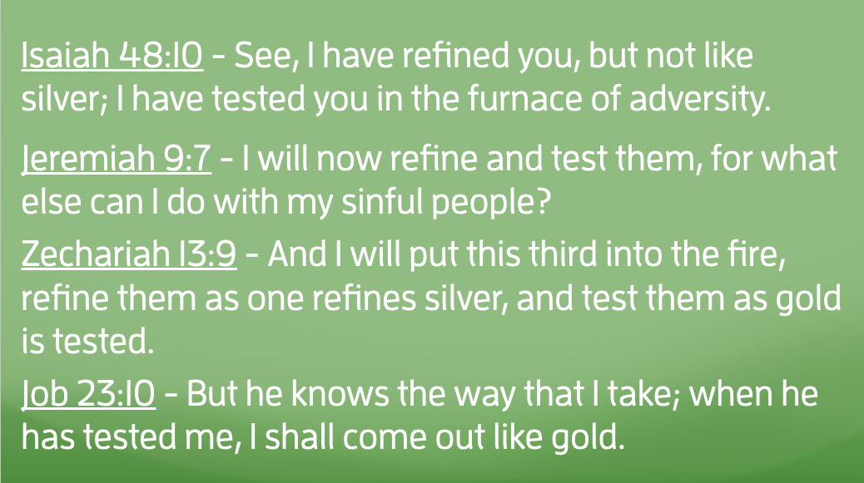
You see, throughout the biblical narrative, it’s common for the people of God to use the terminology of being tested to describe the nature of their hardships:

Isaiah 48:10 - See, I have refined you, but not like silver; I have tested you in the furnace of adversity.
Jeremiah 9:7 - I will now refine and test them, for what else can I do with my sinful people?
Zechariah 13:9 - And I will put this third into the fire, refine them as one refines silver, and test them as gold is tested.
Job 23:10 - But he knows the way that I take; when he has tested me, I shall come out like gold.
The Israelites went through various hardships, and many of them were nothing more or less than being caught up in geopolitical power struggles. And in the midst of these times of disorientation, the poet-prophet is called from among the people to contextualize that suffering within a theological framework. In the case of Psalm 66, the psalmist uses three different metaphors to speak of this testing.

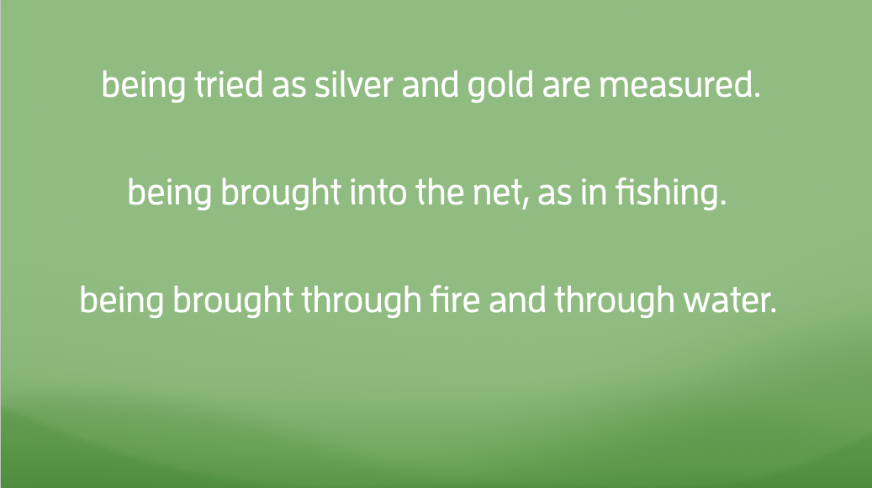
1) being tried as silver and gold are measured. Just as precious metals are only as valuable as their purity, so too must the people of God be measured in their fidelity to God’s covenant.
2) being brought into the net, as in fishing. Just as mature fish must be separated from younglings which are thrown back into the water to grow more, the people of God are called to spiritual maturity.
3) being brought through fire and through water. From a narrative perspective, this is probably the most powerful of the three. It conjures to mind, among others, two major stories of the Hebrew Scriptures. The first is the story of Shadrach, Meshach, and Abednego being thrown into the feiry furnace of King Nebuchadnezzar in the Book of Daniel to be saved miraculously by an angel of God. The second, of course, is the story of the Israelites being led through the Red Sea.
Through these three metaphors in Psalm 66, the Psalmist is crystal clear: “We’ve been through the ringer, y’all! Yet, yet, God has brought us out to a spacious place!”
There are times, dear friends, when it might seem that we’re stuck in some kind of cosmic game of Wipeout. The bible gives us stories of fire and water to describe them. I wonder what metaphors you would use to describe the gauntlets you’ve been through.
And yet, we must never let those trials and tribulations keep us from that divine “yet.” “Yet,” the Psalmist says, those tests did not have the final word. “Yet,” they insist, “God has listened and heard our words of prayer.” Yet,” the voice of the poet says, “God has brought us to a spacious place.”
And so, does God test us? Yes. Does that answer every question we have as to the nature of our hardships? Of course not. But the Psalmist calls us to hold two truths in creative tension with one another. God is both the one who tests and the one who provides.
Yesterday, Tricia, the girls, and I drove to Winston to gather in Wait Chapel for Wake Forrest’s commencement ceremony. My sister, Sarah Kate, graduated with her Masters Degree in Mental Clinical Health Counseling. Before my sister walked the stage, they had the hooding ceremony for the doctoral candidates. One of the things that’s different between doctoral and masters is that masters degrees are conferred by a single faculty member.

The doctoral degrees, however, are conferred to each person by their specific academic advisor. As the person goes to the stage, they are met by their advisor, someone who they’ve gotten to know very well over the past years. The purpose of an academic advisor is to shepherd, challenge, and encourage the person through the research and dissertation process. It’s an incredibly intimate relationship. After years of grueling classwork, research, and writing, the relationship between student and advisor is one that has its ups and downs. However, through those struggles, it’s the role of the academic advisor to do everything they can to make sure that by the time their student gets ready to defend their dissertation that they are 100% prepared.
And when that day comes that the candidate walks along the stage, the one who places their hood over their shoulders is none other than their academic advisor, beaming with pride, who has done their best to cheer them along every step of the way.
Perhaps, my neighbors, that’s a fitting metaphor for a God who tests us. Not some cruel, malevolent God who finds pleasure in our sufferings. But, rather, a divine academic advisor who’s greatest fulfillment is found when we succeed, when we thrive, when we run the race of faith and fight the good fight, as Paul would put it.
The day will come, my neighbors, when our portion of this race is run and we’ll find ourselves at the heavenly commencement ceremony. And I’m convinced, that God will be waiting for us with open arms to say, “You ran the race. You fought the good fight. Well done, my beloved child. Come rest in this spacious place.”
But I’m also convinced that we won’t have to wait until we depart this life for the next in order to receive that affirmation. You and I together are members of a Beloved Neighborhood, a community called Guilford Park Presbyterian Church, where we’re all just people doing the best we can do in this thing called life. Together, we cheer one another along, giving thanks to a God who both tests us and provides for us as we run this race of faith.
In the name of God the Creator, Redeemer, and Sustainer, may all of us, God’s children, say: Amen.

https://en.wikipedia.org/wiki/Schadenfreude

