5th Sunday after Epiphany (Year A)

__________________________________________________________________________________________

Matthew 5:14-16 (Cotton Patch Version)

Y’all are the world’s light; you are a city on a hill that cannot be hid. Have you ever heard of anybody turning on a light and then covering it up? Don’t you fix it so that it will light up the whole room? Well then, since you are God’s light which he has turned on, go ahead and shine so clearly that when your conduct is observed it will plainly be the work of your spiritual Father.”
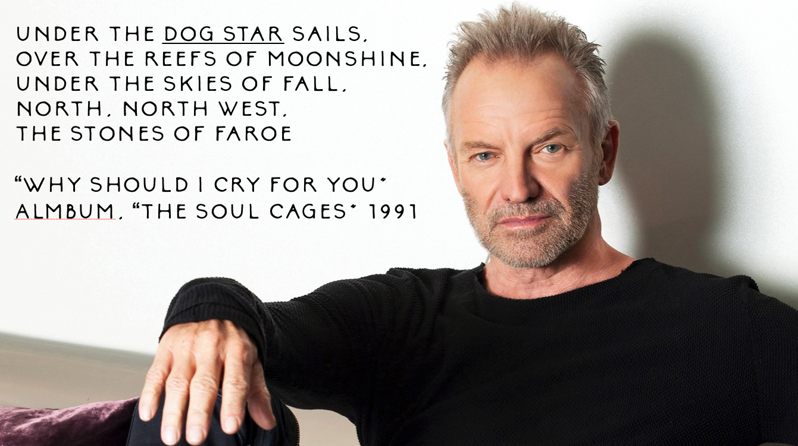
__________________________________________________________________________________________
Under the dog star sails,
Over the reefs of moonshine,
under the skies of all,
north, northwest, the stones of Faroe.
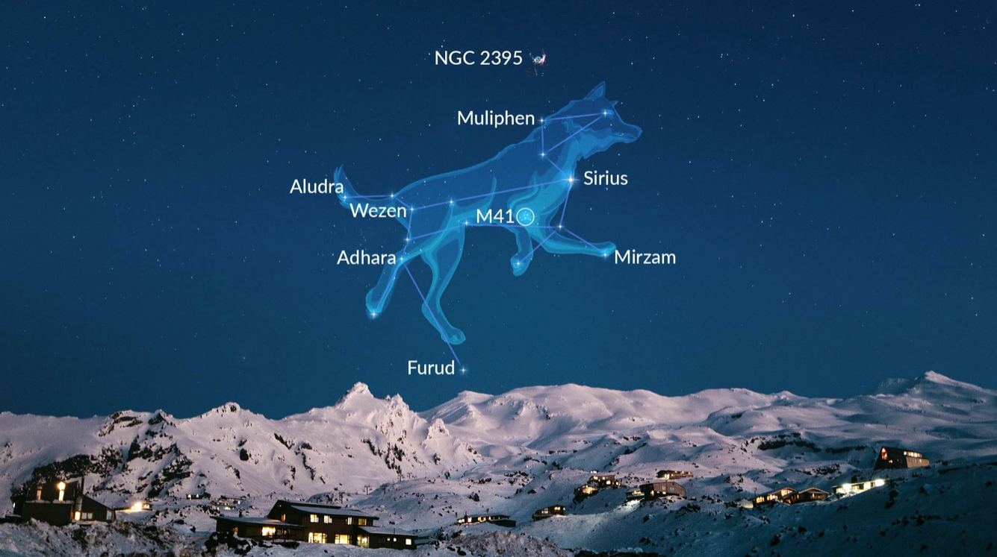
These lyrics are the beginning of perhaps my favorite song from one of my favorite musical artists, Sting. They are the opening lines of his song “Why Should I Cry for You.” Nautical references are frequent in the canon of his legendary discography which is understandable seeing as he grew up in Wallsend, a shipbuilding town in northern England on the coast of the North Sea. Growing up watching the massive ships being built and “blotting out the light of the sun,” Sting had many encounters with sailers. And in many of Sting’s songs, including this one from the 1991 album, “The Soul Cages,” invoke “the dog star.” For years, I’ve listened to and sung that song without knowing exactly what a “dog star” is.
Well, it turns out that it’s a colloquial term used by sailors for Sirius, the brightest star in the sky. The Dog Star is so named because it is a part of the image of the dog constellation in the night sky. Any Harry Potter fans will know why it is that Harry’s godfather, Sirius, transfigures into a dog whenever he wants to.
Sailers always look for the dog star because it’s the easiest to find and is key to navigating the waters of the dangerous seas. And in this particular song by Sting, he uses the beauty, mystery, and danger of navigating the seas as a metaphor for examining his complicated feelings following the death of his father. I say this because we all know what it feels like to be lost at sea, seeking guidance, looking for the dog star to recenter us and help us find our way. But sometimes that dog star eludes us. Stormy seas and cloudy skies leave us disoriented. Over the trials and tribulations of this life we can forget its place in the sky or wonder whether we left it or it left us. Few feelings are as agonizing and lonely as feeling like we’ve lost our way. And, truth be told, we can be lost through no fault of our own, and for no reason other than it’s just part of the human condition.
And in the wake of that truth, we find today’s passage from Matthew’s Gospel (or perhaps it finds us?). “You are called to be the world’s light,” Jesus says, “a city on a hill that cannot be hid.” In those words, I hear Jesus saying, “you are called to be the dog star, shining for others to find their way when all seems lost.” “You are called,” Jesus says, "to be the brightest star in the sky; the dog star.”
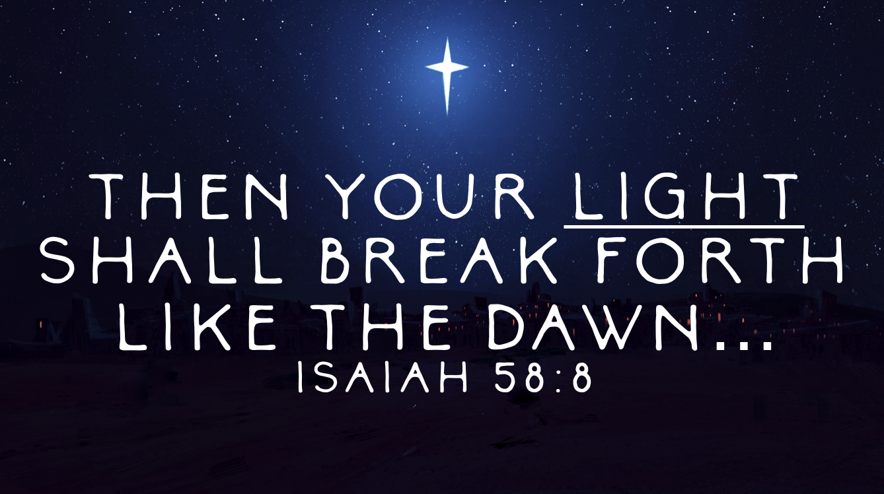
What does that mean? Well, this is a point when the lectionary helps us by giving us two other passages that mention light and perhaps we might learn something if we allow these scripture to converse with one another.
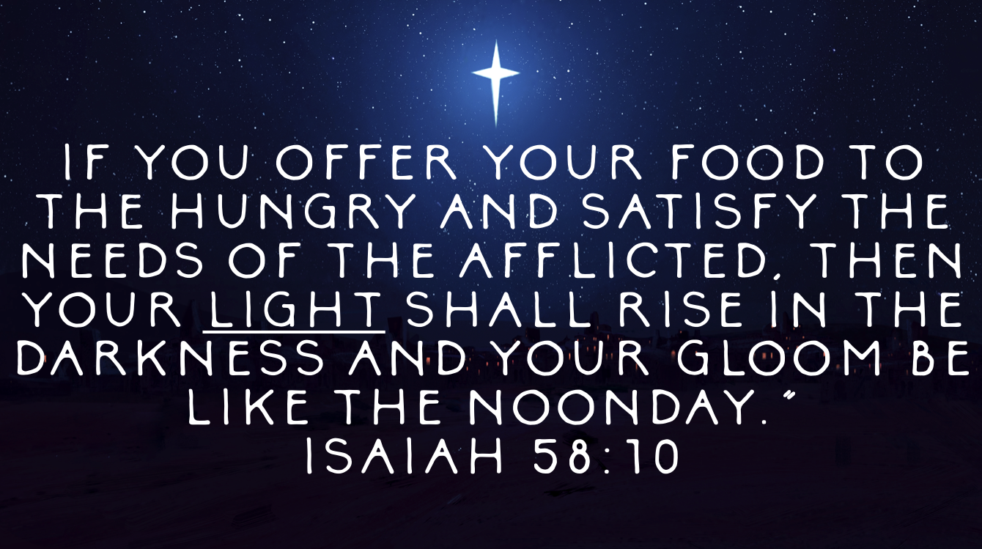
First let’s look at the Isaiah passage. We didn’t read it today but we’ll visit it in a few short weeks on Ash Wednesday. In the 58th chapter of Isaiah, God speaks through the voice of the prophet God’s displeasure at the Israelites’ tendency to prioritize their pious worship practices over and above their responsibility to feed the hungry, clothe the naked, and “bring the homeless poor into their homes.” If and when they do those works of righteousness, God says, “then your light shall break forth like the dawn.”
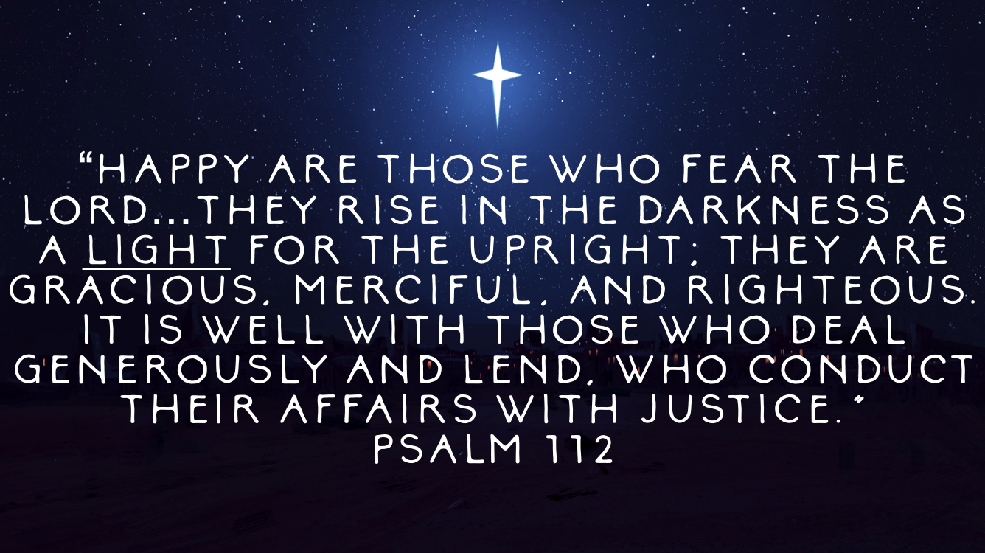
Later in the chapter, God reiterates this by saying “If you offer your food to the hungry and satisfy the needs of the afflicted, then your light shall rise in the darkness and your gloom be like the noonday.”
The psalm we read a few minutes ago also makes mention of light. In it we read the following: “Happy are those who fear the Lord…they rise in the darkness as a light for the upright; they are gracious, merciful, and righteous. It is well with those who deal generously and lend, who conduct their affairs with justice.”
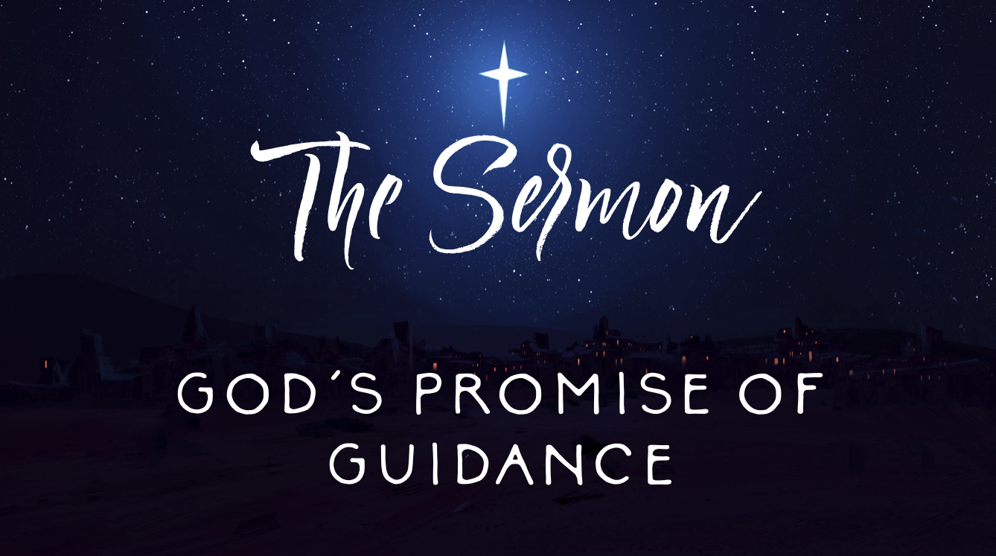
And so, based off of these two other lectionary texts, we can presume that those who are the “dog star” to others, those who are the “light of the world,” are those who “conduct their affairs with justice,” and “those who offer food to the hungry and satisfy the needs of the afflicted. “ And that would certainly be in keeping with the wider context of the Sermon on the Mount. Remember, just last week we traveled through the Beatitudes and reminded ourselves that Jesus reverses the narrative of the honor/shame culture of that day. Blessed, he said, are the weak of breath. Blessed, he said, are the poor in spirit. Blessed, he said, are those who mourn and those who are persecuted. Blessed, he said, are those whose backs are bent with the weight of the world. Blessed, we might say in the context of today’s passage, are those who share God’s light with the world. Blessed, we might say, are those who seek God’s guidance for themselves and their neighbors.

And the folks here at Guilford Park Presbyterian Church do that in some very concrete ways:
After we journeyed through the Beatitudes last week, y’all gave more than $1,200 in loose offering that went into the deacon’s fund, which was used twice this week to write checks paying for the outstanding utility bill balances for two families in need referred to us by Greensboro Urban Ministries.
On a personal note, one of the ways y’all have been God’s light to me is by reaching out to me to ask how my father’s prostatectomy went. For the record, it went well and my father is in good spirits. But I’ve received so many letters and notes of prayer, well wishes, and encouragements. Y’all have shown God’s light to me and I know that it’s not just me! I know that happens all the time around here with various people who need to be guided to God’s light in times of stress and anxiety and fear.
This congregation is the light of the world when we gather to remember the immortal words of Martin Luther King who reminds us that predominantly white congregations such as ourselves still have much work to do in the world to build a more fully antiracist neighborhood and society.
This congregation is the light of the world when the Guilford Guys gather on Thursday evenings to hold space for the young men in transitional housing. This congregation is the light of the world whenever we volunteer at places like Greensboro Urban Ministry and the Pathway Center, where food, shelter, and supportive services are given to those who are weak of breath without access to stable, affordable housing.
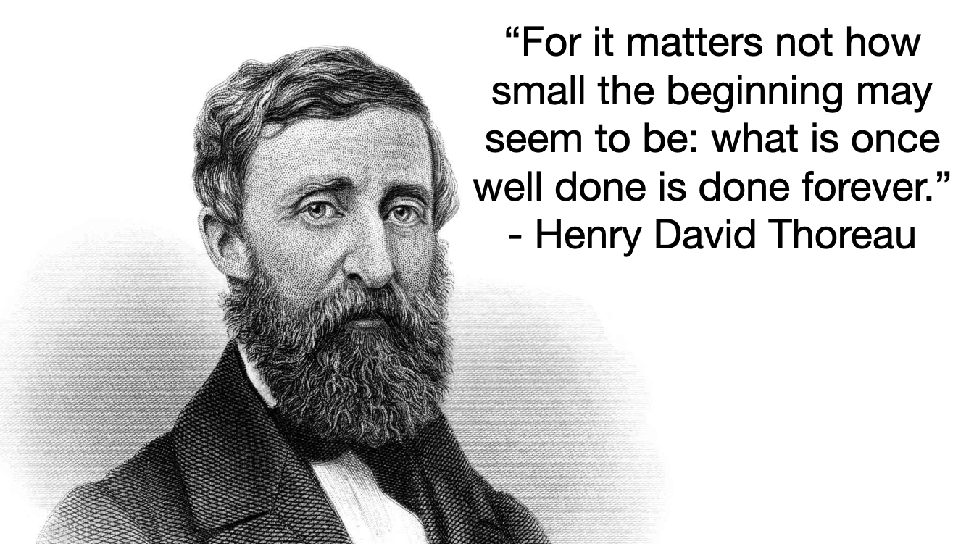
This congregation is the light of the world whenever we gather in this room and elsewhere to pray, sing, preach, and praise in God’s name. We are the light of the world in ways both big and small. Y’all, it doesn’t take football stadium lighting systems to get the job done. Have any of y’all ever been caving, or spelunking? Have y’all ever experienced total darkness in a chamber beneath the earth’s surface where there is literally no light? One candle is all it takes to light up a cavern. Your contribution matters. Your ministry matters. The promise of God’s guidance matters.
As Henry David Thoreau once said, “it matters not how small the beginning may seem to be; what is once well done is done forever.”
And, I’ll close with these two brief reminders. The first is this and it’s not the first time I’ve said this from this pulpit: we are not called to do ministry alone, we’re called to ministry in community. We’re not called to be the light of the world alone, we’re called to be the light of the world together. Last week, one of my favorite moments in worship was when the acolytes were struggling to light the candles in the rear of the sanctuary. As Liam Padgett and Ross Beale walked down the aisle to light the candles in the back, their flames struggled to stay lit. And so they helped each other. They got to the back and Bill Hickling helped them. One flame went out and so the flame from another candle was used to get the job done. Friends, that’ll preach! We need each other to keep ourselves where the light is!
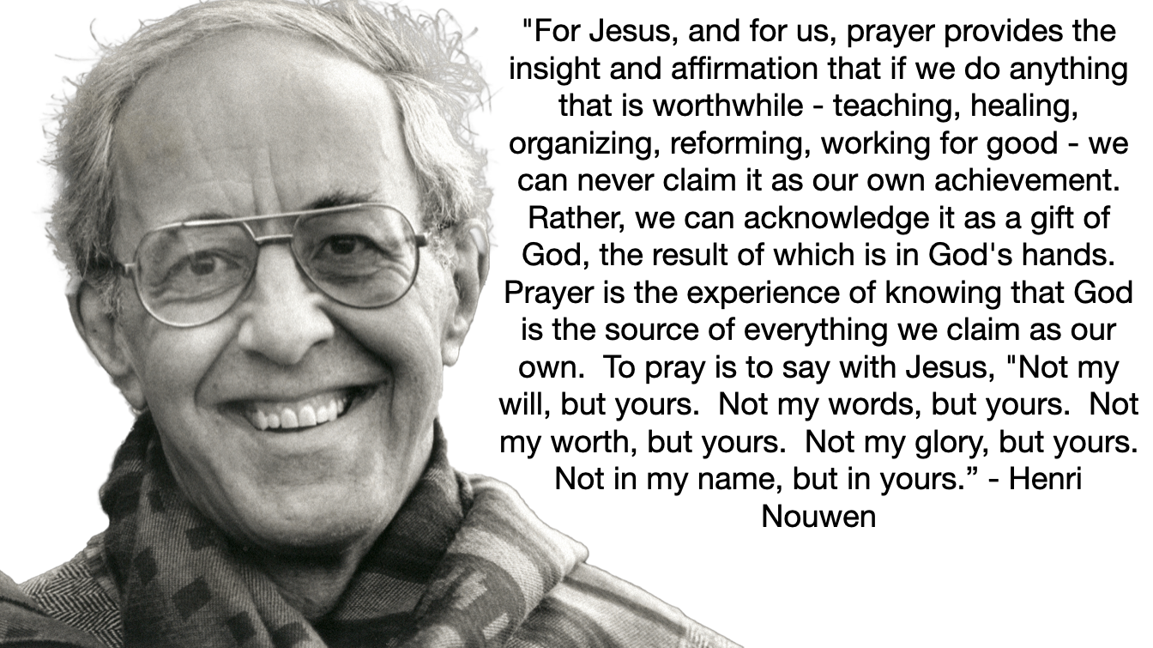
And finally, an important reminder that we ourselves are not the source of the light. When Christ tells the disciples to go into the world to be the world’s light, he’s not saying that the light is coming from them, but rather that they are ambassadors for the light, vehicles for the light. In other words, my friends, we’re just the flashlight; God’s the battery. These things that I lifted up as concrete examples of how Guilford Park Presbyterian Church is being the light of the world are not ways to take credit for something we’re doing ourselves or by ourselves. Rather, they are offered in gratitude that it is God who is doing those things through us. That’s how we receive the promise of God’s guidance; by practicing sharing that light with one another and our neighbors.
It reminds me of this great quote from Henri Nouwen: "For Jesus, and for us, prayer provides the insight and affirmation that if we do anything that is worthwhile - teaching, healing, organizing, reforming, working for good - we can never claim it as our own achievement. Rather, we can acknowledge it as a gift of God, the result of which is in God's hands. Prayer is the experience of knowing that God is the source of everything we claim as our own. To pray is to say with Jesus, "Not my will, but yours. Not my words, but yours. Not my worth, but yours. Not my glory, but yours. Not in my name, but in yours.”
In the name of God the Creator, Redeemer, and Sustainer, may all of us God’s children say, Amen.

