Ascension of the Lord (Year A)

__________________________________________________________________________________________

Psalm 47

Clap your hands, all you peoples;
shout to God with loud songs of joy.
For the Lord, the Most High, is awesome,
a great king over all the earth.
He subdued peoples under us,
and nations under our feet.
He chose our heritage for us,
the pride of Jacob whom he loves. Selah
God has gone up with a shout,
the Lord with the sound of a trumpet.
Sing praises to God, sing praises;
sing praises to our King, sing praises.
For God is the king of all the earth;
sing praises with a psalm.
God is king over the nations;
God sits on his holy throne.
The princes of the peoples gather
as the people of the God of Abraham.
For the shields of the earth belong to God;
he is highly exalted.
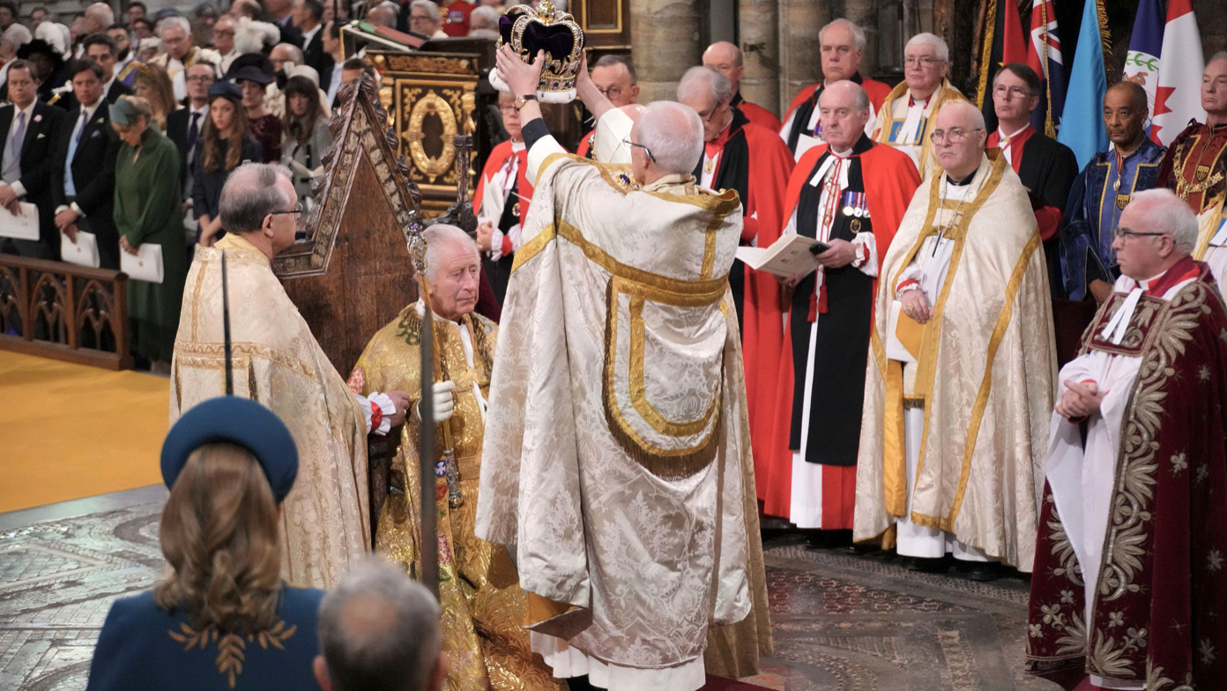
__________________________________________________________________________________________

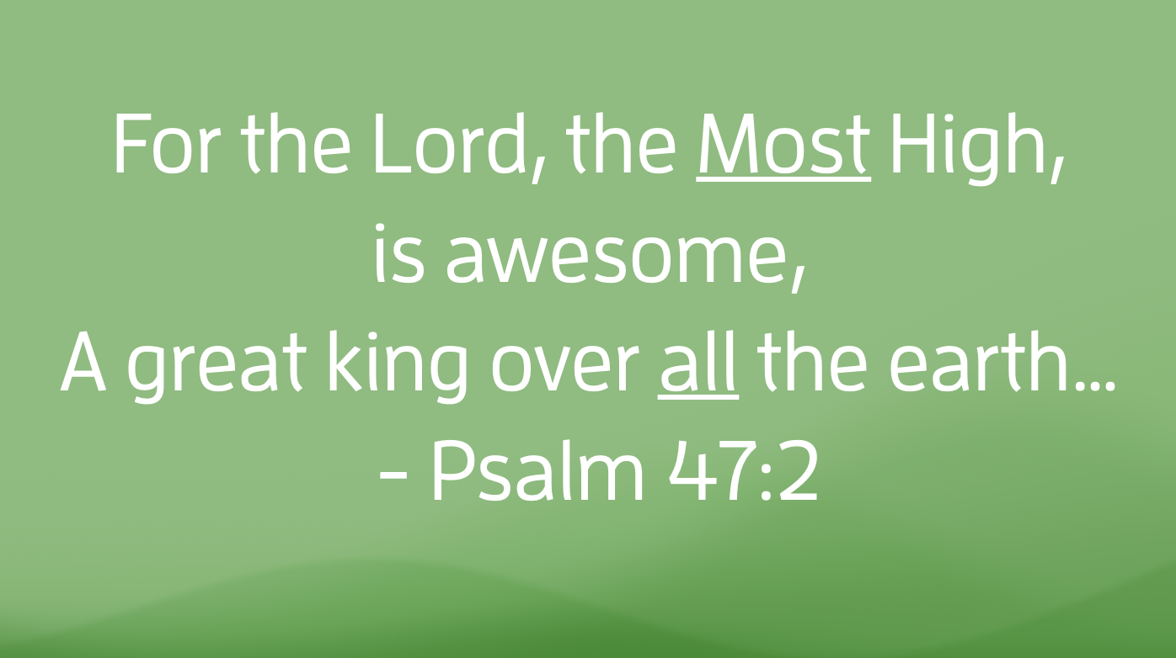
A few weeks ago, King Charles III was officially crowned King of the United Kingdom. Having succeeded his mother, Queen Elizabeth II, Charles assumed the throne upon her death last year and was coronated on May 6. As I slept soundly in our bed, my wife Tricia, ever the Anglophile, woke up at the crack of dawn to watch the pageantry. I was content to watch the summary on the news later that day. It was, of course, a grand event with unmatched attention to every ritualistic detail. Songs of acclamation were sung. Liturgy was recited. Parades marched through the streets of London. Oil was anointed upon Charles’ head, preparing the way for the crown that would soon be placed upon him. Many a “Long Live the King” was uttered throughout the Kingdom and perhaps by some here on this side of the pond.
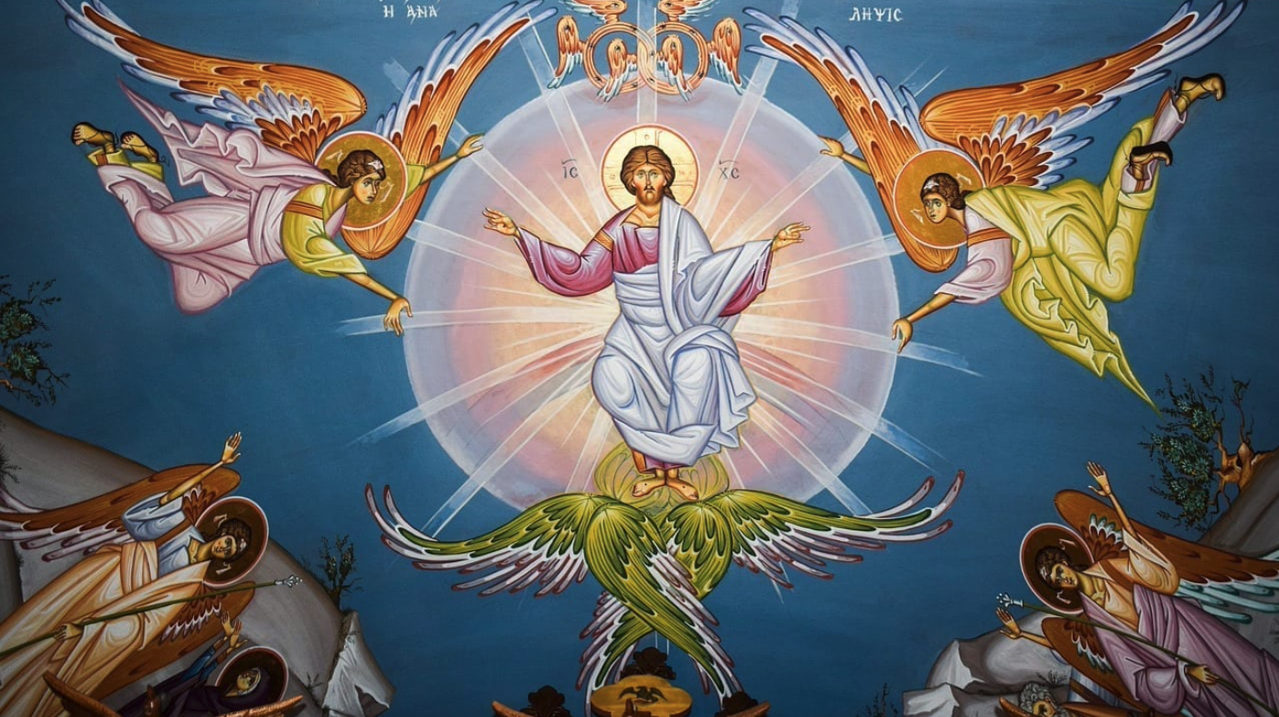
Long before the United Kingdom ever was, the Psalmist penned this hymn giving similar acclamation to a king of a different kind. Psalm 47 is a brief psalm with a clear and concise message: God reigns supreme. God is king over the nations. God sits on God's holy throne. God is in charge.
It isn’t surprising then that the church has used this Psalm on the occasion of the Ascension of the Lord, which is observed on this day, the Sunday prior to Pentecost. It’s the Sunday that gives us the reason for saying “he ascended into heaven” whenever we recite the Apostles’ Creed together. It’s the decisive moment when the resurrected Christ takes his position “at the right hand of the Father,” solidifying his victory over death. The words of Psalm 47 are fitting for the occasion, as we turn our attention to Pentecost and celebrate the birth of the Church and our continued work in Christ’s name.
At first glance, Psalm 47 might seem a rather harmless piece of scripture. But on this Ascension Sunday, Psalm 47 reminds us that if we claim God as the ruler of all creation, then that means that everything and everyone else doesn’t get that title. You see, from the get-go, God understood that we humans have a tendency to worship a lot of things: money, violence, power. We all know what it’s like to be in the shoes of Shadrach, Meshach, and Abednego, being told that our worship belongs to idols that destruct instead of the one true God, the giver of life. Hopefully, none of us have been literally threatened with being thrown into a burning furnace, but the fires of temptation still rage around us in this complex world.
Sometimes those golden calfs come in different forms. Sometimes they look like assault rifles. Sometimes they look like our stock portfolios, investing in companies that conduct their businesses in ways that hurt people and harm creation. Sometimes the golden calfs look like a border wall or a thinly-veiled piece of legislation whose true purpose is to marginalize a group of people. Whatever forms those golden calfs take, they all serve the same purpose: to distract us from worshiping the God who gives life, loves justice, and distributes mercy at every turn.
And in the midst of that sea of distraction comes the poet with the words of Psalm 47, turning our attention to a God who reigns supreme. Walter Brueggemann has called this psalm a “disruptive metaphor” because it interrupts the narrative that “oppressive regimes seem to be eternally guaranteed.” Whether that regime is a political one or an ideology of oppression such as racism or homophobia, those powers and principalities purport themselves to be almighty. Psalm 47 begs to differ. And there are times when the Church needs this disruptive metaphor to rid us of complicity in ideologies that harm creation.
German Christians found themselves caught up in such a time in the 1930’s. As Hitler rose to power, fueled by a sea of resentment of a people who felt they had been wronged, his fascist ideology infiltrated the churches of Germany. The Third Reich attempted to co-opt the Christian Church to strengthen its foothold and consolidate its power. Swastika banners began to show up in churches. German pastors began either preaching supportive messages of Hitler’s regime or turning a blind eye and deciding the safer option was to say nothing to maintain “the unity” of the church.
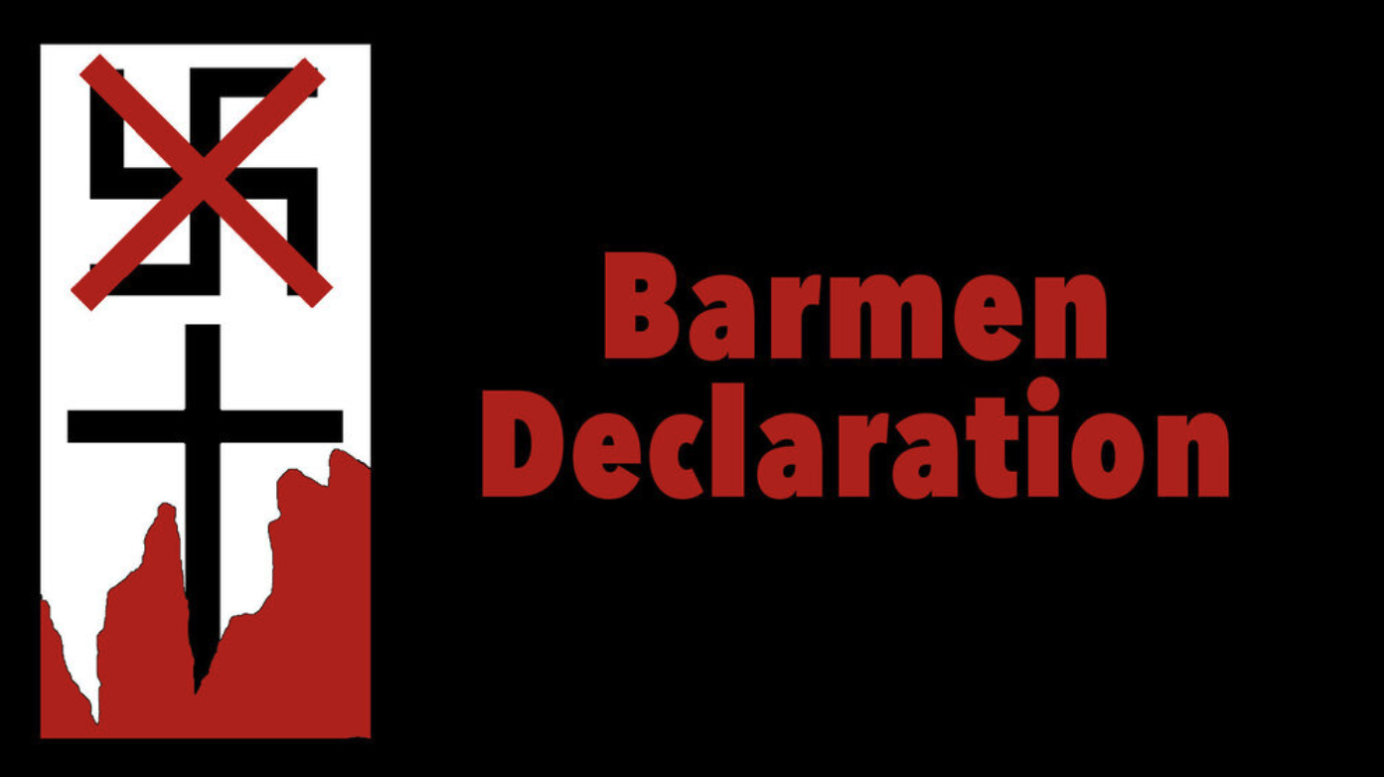
Our denomination’s Book of Confessions says the following of this dark period in our history: “Most Germans took the union of Christianity, nationalism, and militarism for granted, and patriotic sentiments were equated with Christian truth. The German Christians exalted the racially pure nation and the rule of Hitler as God’s will for the German people.”
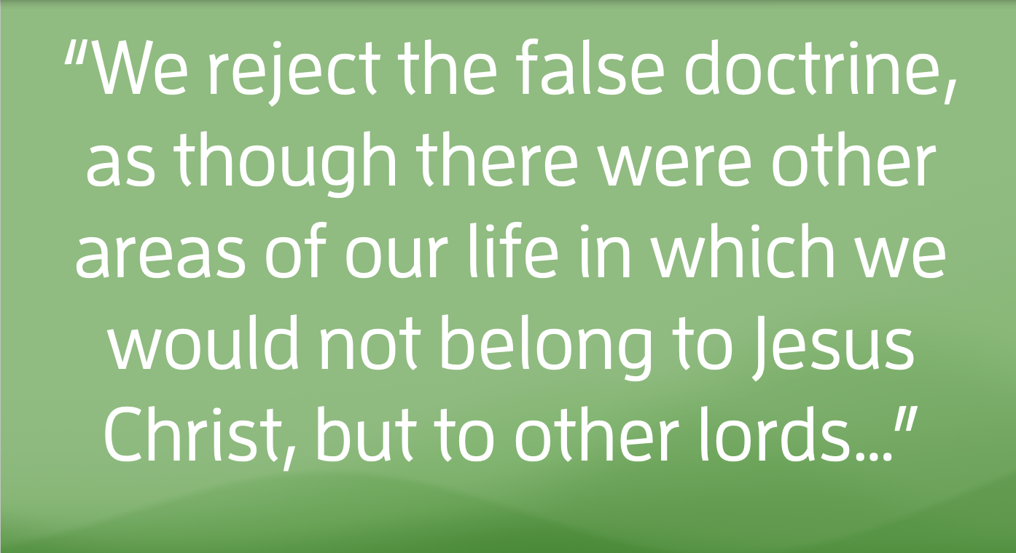
But the theology of Psalm 47 led many Christian pastors to refute Nazi ideology and speak up. Nearly 90 years ago, in 1934, one hundred and thirty-nine pastors, fifty-three church members, and six university professors gathered in Barmen, Germany and wrote “An Appeal to the Evangelical Congregations and Christians in Germany” refuting the sovereignty of Hitler’s Nazi party.
In it they said, “We reject the false doctrine, as though there were other areas of our life in which we would not belong to Jesus Christ, but to other lords…”
God is king over the nations, Psalm 47 sings; God sits on God’s holy throne. The authors of what would become known as the Barmen Declaration defiantly asserted that there is only one god sitting on the throne, and his name wasn’t Hitler. And to this day, the Barmen Declaration is one of our denomination’s guiding confessions, reminding us of our duty to resist any and all ideologies that destruct creation and harm our neighbors.
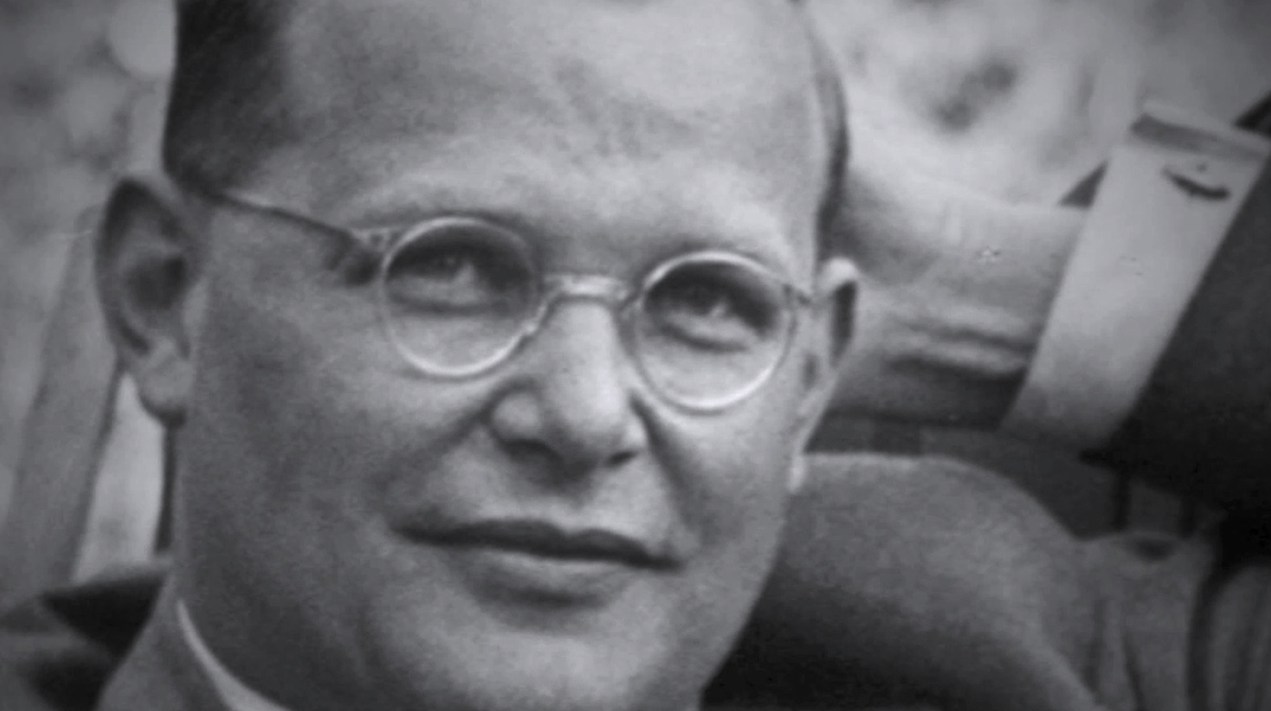
The authors of that document made a choice. And that choice had consequences. I doubt their churches were the most well-attended after they drew a line in the sand. Some of them had to flee the country because of death threats. Some lost their jobs.
Some, like Dietrich Bonhoeffer, lost their lives because of their allegiance to God over and above a political ideology that consolidated power by oppression.
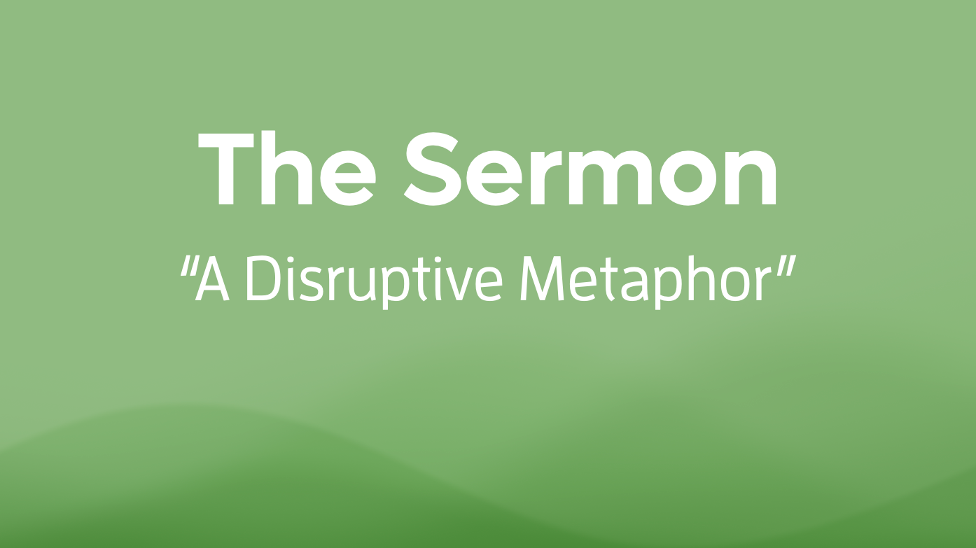
Our choices have consequences. And make no mistake about it, those decisions are complicated ones. I imagine the German Christians who signed the Barmen Declaration knew that they were putting themselves, their families, and their congregations at risk. But in their minds, the risk of saying nothing was far greater than the risk of speaking up. I want my daughters to know the story of the Barmen Declaration, because I want them to know that doing the right thing doesn’t always make one the most popular, or prestigious, or powerful, or rich. Sometimes, being a Christian means doing something not because it is easy, or fashionable, or flashy, but sometimes we do what we do because God is king and that means everything and everyone else isn’t. This, of course, doesn’t mean that we can’t be part of other groups. We don’t have to choose between being a faithful Christian and practicing healthy patriotism, for example. But when we’ve turned our country into a god and worship it with the same, or even greater, passion as we do our God, that is the moment that the song of Psalm 47 comes to a crashing halt.
Giving God our ultimate allegiance has real consequences. It changes the way we spend our money. It changes the way we spend our time. It changes the ways we interact with our neighbors or raise our children. But lest we lose ourselves in despair over the difficulty of those decisions, we rest in the fact that our allegiance is given to a God who has given us ample reasons to trust that those other idols will eventually return to the dust of the earth. One day, my friends, King Charles III will be no more. One day, all the other powers and principalities will fall. This nation isn’t eternal. Neither are its political parties. The powers that seek to divide us from our neighbors will sputter and die just as the Nazi party did when enough people stood up to say, “God is king and Hitler is not.”
So friends, I pray that you never find yourself in the position to put your life in danger to maintain your fidelity to God. That extreme example aside, there are millions of other ways, great and small, that our allegiance to God makes a difference, a real tangible difference, in our world and in our neighborhood. Today we’re gifted with this “disruptive metaphor” that calls into question the legitimacy of any ideology that harms our neighbor.
So when you hear a voice that says that your neighbor is your enemy, that voice is not the voice of God.
When you hear a voice that says that the most important thing is your money, or your power, or your privilege, that voice is not the voice of God.
When you hear a voice that says that your allegiance to this nation or any political party is more important that your allegiance to Christ, that voice is not the voice of God.
Those voices need disruption. And Psalm 47 helps us push them aside to make room for the mighty voice of God who breathed life into all creation and speaks a word of peace to violence, justice to oppression, and mercy to hatred. Together, let us worship the King, and only the King.

