_____________________________________________________________________________
Matthew 18:21-35
`Then Peter came and said to him, ‘Lord, if another member of the church sins against me, how often should I forgive? As many as seven times?’ Jesus said to him, ‘Not seven times, but, I tell you, seventy-seven times.
‘For this reason the kingdom of heaven may be compared to a king who wished to settle accounts with his slaves. When he began the reckoning, one who owed him ten thousand talents was brought to him; and, as he could not pay, his lord ordered him to be sold, together with his wife and children and all his possessions, and payment to be made. So the slave fell on his knees before him, saying, “Have patience with me, and I will pay you everything.” And out of pity for him, the lord of that slave released him and forgave him the debt. But that same slave, as he went out, came upon one of his fellow-slaves who owed him a hundred denarii; and seizing him by the throat, he said, “Pay what you owe.” Then his fellow-slave fell down and pleaded with him, “Have patience with me, and I will pay you.” But he refused; then he went and threw him into prison until he should pay the debt. When his fellow-slaves saw what had happened, they were greatly distressed, and they went and reported to their lord all that had taken place. Then his lord summoned him and said to him, “You wicked slave! I forgave you all that debt because you pleaded with me. Should you not have had mercy on your fellow-slave, as I had mercy on you?” And in anger his lord handed him over to be tortured until he should pay his entire debt. So my heavenly Father will also do to every one of you, if you do not forgive your brother or sister from your heart.’
_____________________________________________________________________________
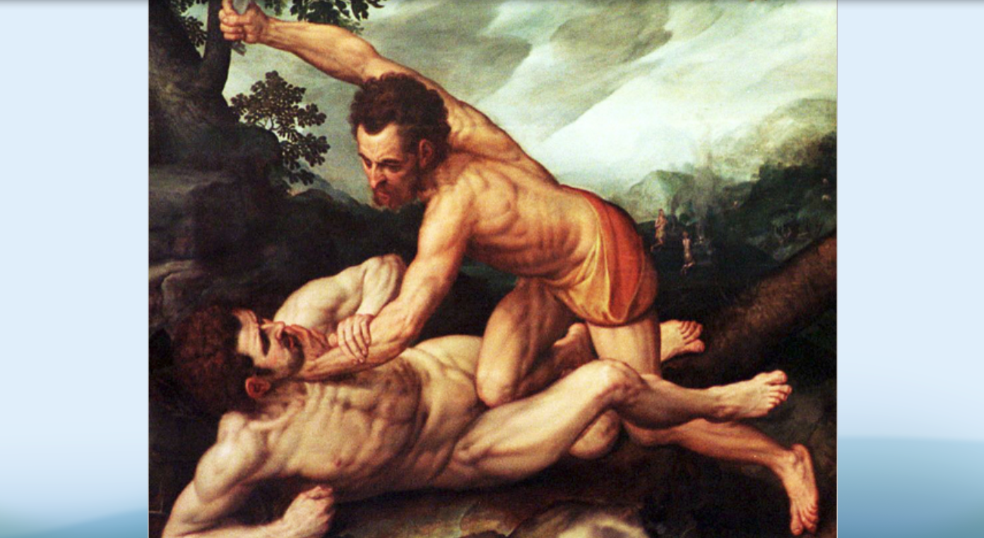
Let me tell you a story about a man named Lamech. There are many important characters in the Book of Genesis and I suspect you could join me in naming several of them: Eve and her husband Adam, Sarah and her husband Abraham, Noah and his family, Jacob and his brother Esau, Rachel and Leah, Joseph and his brothers. But Lamech is a character that rarely makes that list. I suppose it’s mostly because he is only mentioned briefly in the fourth chapter of Genesis. You see, Lamech is a direct descendant of Cain. Therefore, in order to understand Lamech’s brief but violent tenure in the Book of Genesis, a little bit of context is in order.
Cain is, of course, more infamous than famous. His act of violence is the first of many in the Biblical narrative. Cain had a brother named Abel and no matter how hard he tried, Cain could never quite measure up to him. God preferred Abel’s offerings over Cain’s and Cain just couldn’t let it go. He seethed in anger. God noticed and sat down with Cain and told him to be careful; and that he had the capacity to control his anger and avoid bloodshed. But Cain didn’t listen. Instead, he took his brother out to the fields and murdered him.
And God was horrified. God foresaw an impending cycle of violence, a truth that you and I know too well in the world around us. God knew that violence begets violence and God refused to endorse that philosophy. Cain suffered the consequences, yes; he was banished from the land as the very ground cried out in agony in disgust of the violation of God’s Creation. But Cain was nevertheless shown mercy. God marked Cain to protect him. God marked Cain to break the cycle of violence.
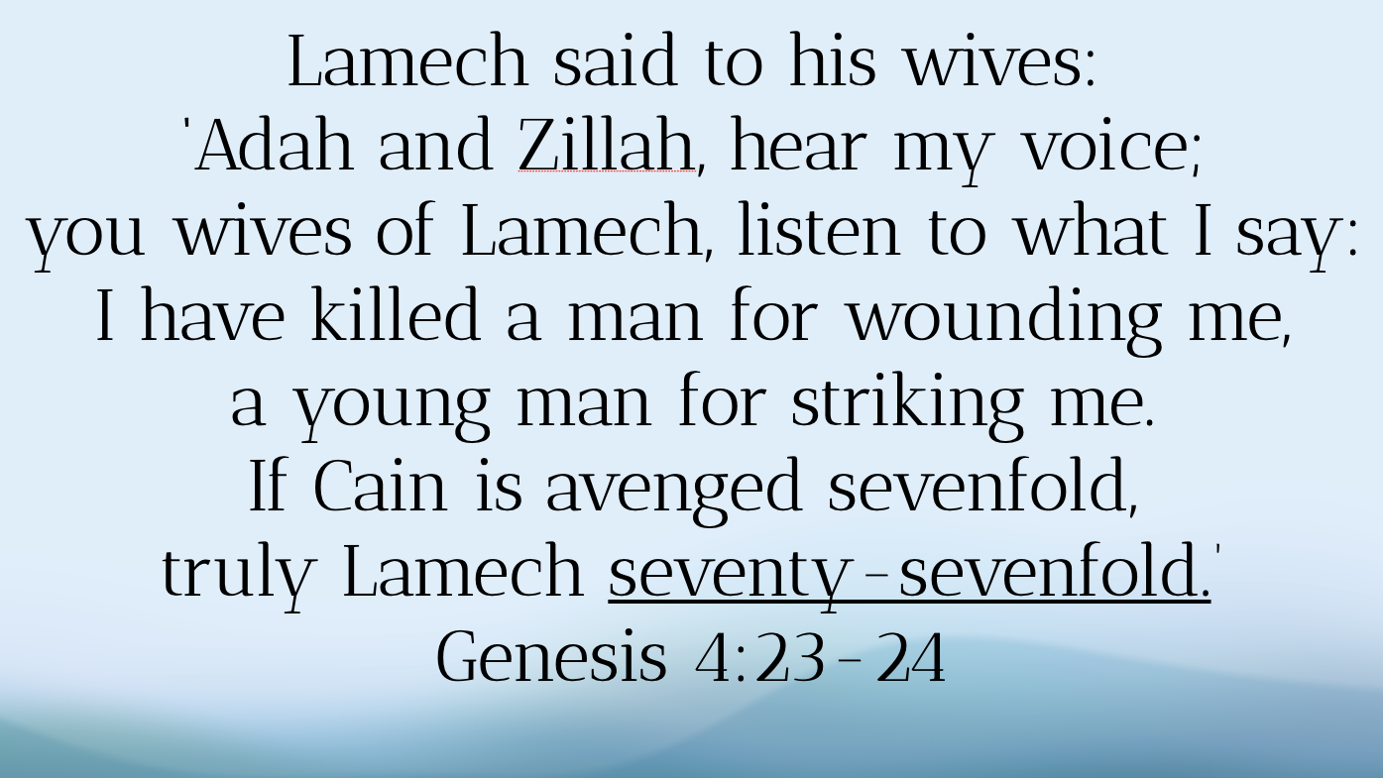
Fast forward a few generations and we’re introduced to a grandchild of Cain by the name of Lamech and Lamech had no interest in God’s policy of nonviolence. Instead, he brags and boasts about his capacity for vengeance. If someone insults him, he’ll cut off the other person’s arm. If someone slaps him, he’ll murder them. Lamech sees God’s policy of nonviolence as weakness. Lamech beats his chest and yells that the source of his strength is his capacity for vengeance. This is what Lamech says in Genesis 4:23-24:
Lamech said to his wives: ‘Adah and Zillah, hear my voice;
you wives of Lamech, listen to what I say:
I have killed a man for wounding me, a young man for striking me.
If Cain is avenged sevenfold, truly Lamech seventy-sevenfold.’
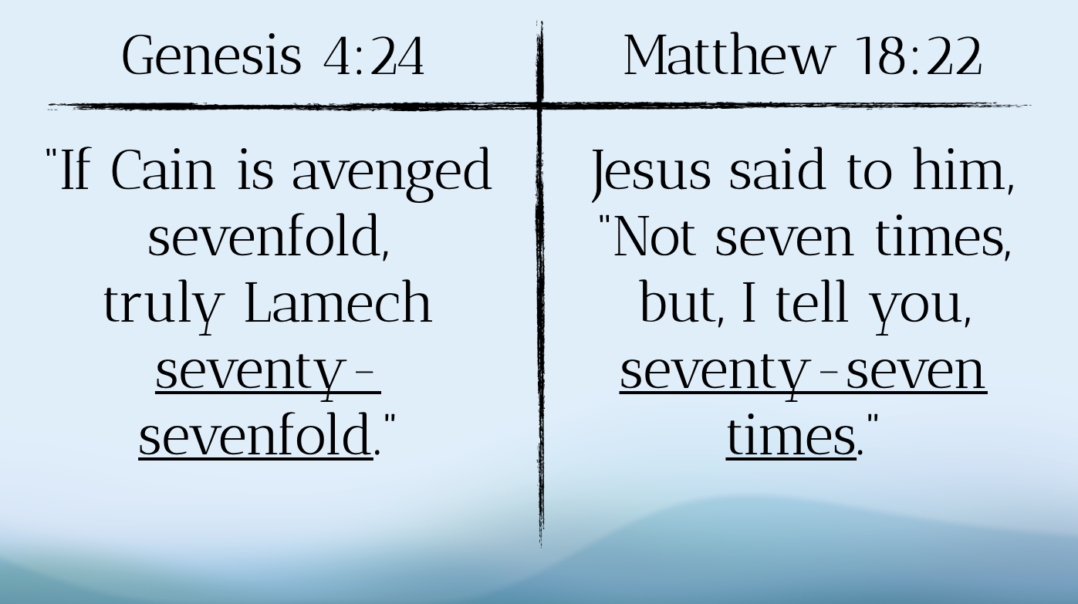
Does the sound of that voice seem familiar to you? Cause it does to me. It’s a voice that we know all too well. It’s a voice of vengeance that has come to drive much of the politics in our country these days. It’s a voice that, if we are to be brutally honest, lives within you and it lives within me. We all have the capacity and, yes, even the urge to lash out when we are wronged.
And I think Jesus knew that in today’s passage because Jesus uses that same number, the number 77 that Lamech uses to describe the number of times that he’ll lash out in vengeance.
You see, you gotta love Peter because Peter asks the question that everyone wants to ask but is too scared to ask. Peter asks how many times he should forgive someone and Jesus responds with not seven but 77 times. Jesus knows that Peter is well versed in the Hebrew Scriptures and knows the story of Lamech. Furthermore, the author of the Gospel of Matthew is writing to a predominately Jewish audience so they know that the readers will know the story of Lamech as well.
In citing the number 77, Jesus is trying to undo the vengeance of Lamech. In citing the number 77, Jesus is trying to break the cycle of vengeance and establish forgiveness as the very stuff of the Kingdom of Heaven, a lifestyle that bears within it the capacity to makes us more righteous instead of more hateful. And to make his point, as he does often, Jesus tells a parable.
You see, there’s this servant who owed an absurdly large amount of money to his king. Without going too much into specifics, let’s just say that the amount of money he owed was a debt that couldn’t possibly be paid off in one lifetime, or even a hundred lifetimes, or even a thousand lifetimes! In fact, some biblical scholars estimate that 10,000 talents was more money than was even in circulation in the entire country at that time! Needless to say, this servant had been forgiven a debt that was unimaginatively burdensome. This servant (not to mention his family as well!) had been reconciled to the community and freed of his debt.
The cycle had been broken. A new alternative had been presented. It’s just like when God sat down with Cain to talk to him before he killed his brother. God said to Cain, “I see what you’re thinking and I’m here to tell you that there is another way to live; a different kind of living that doesn’t resort to violence.” But instead of accepting God’s peaceful alternative, Cain rejected it and chose the easier path, the one that ends in blood. So too, apparently, did his offspring, Lamech, several generations later.
And, sadly, so too did the servant in today’s parable. Instead of promoting this new reality of forgiveness, the servant found someone who owed him a pitifully small amount of money compared to the amount he was just forgiven and grabbed him by the throat to demand the immediate repayment. When the man cannot pay his debt, he had him thrown into jail.
The story does not have a happy ending for anyone. The king is understandably enraged. He attempted to break the cycle and forgave the servant his debt. And what did he do with that forgiveness? He spat it out and continued the very cycle it was intended to disrupt. The servant is tortured and thrown into jail for the rest of his life and we are left with these uneasy words: So my heavenly Father will also do to every one of you, if you do not forgive your brother or sister from your heart.
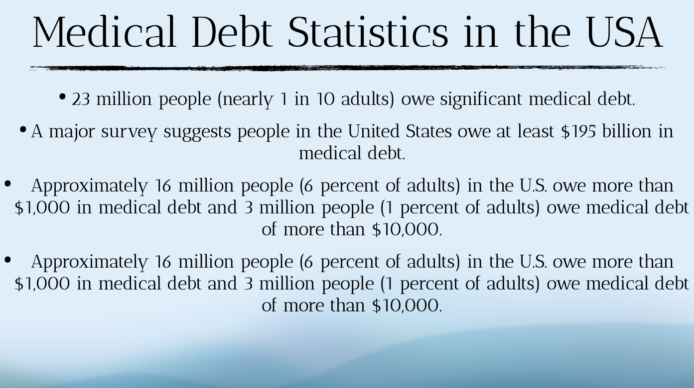
And thus, the parable leaves us with this truth: Jesus takes forgiveness seriously and, therefore, those of us who claim to be his followers must do so as well. It’s as if Jesus is, quite literally, saying that forgiveness is a matter of life and death and we should act accordingly. And if we don’t believe that the forgiving of debts is a matter of life or death, consider these statistics:

- 23 million people (nearly 1 in 10 adults) owe significant medical debt.
- A major survey suggests people in the United States owe at least $195 billion in medical debt.
- Approximately 16 million people (6 percent of adults) in the U.S. owe more than $1,000 in medical debt and 3 million people (1 percent of adults) owe medical debt of more than $10,000.
- Among racial and ethnic groups, a larger share of Black adults (16 percent) report having medical debt compared to White (9 percent), Hispanic (9 percent), and Asian American (4 percent) adults.
So, y’all, this is why I bring up these statistics. I sometimes wonder if we don’t, at times, overly “spiritualize” these conversations of forgiveness. Often, we have the conversation about forgiveness at an individual level, regarding the debt incurred between one person and another. And that certainly isn’t to say that that’s not an important conversation to have or that these passages don’t speak to those situations. But this parable isn’t just about metaphorical debt; it’s about financial debt. It doesn’t just have moralistic ramifications; it has real economic implications as well. And if this parable is to suggest that we are to forgive economic debt for individuals who have ostensibly done something “wrong” to incur such a debt, how much more so should we forgive those who have done nothing wrong to find themselves in a similar situation?
That’s why I bring up the topic of medical debt (and certainly we could go on to talk about other kinds of debt but we’ll leave that for other sermons). I wish to lift up for you the work of a national non-profit that has decided to do the hard but rewarding work of relieving people burdened by medical debt. Their called RIP Medical Debt and I’d like to show you a brief video to explain how they do their work.
[show video]
Some fellow Presbyterian Churches have decided to partner with RIP Medical Debt to help them leverage their donations to purchase medical debt for low-income residents for pennies on the dollar.
Recently, a Presbyterian church in Winona, Wisconsin raised $15,000 and were able to clear approximately $2 million dollars in medical debt owed by about 1,000 families in their neighborhood.
Likewise, the Presbyterian churches in mid-Kentucky Presbytery, not far from where Tricia and I recently lived, raised a similar amount to clear more than one million dollars in debt.
And last year, the churches in the Synod of Mid-America (which encompasses Kansas, Missouri, and southwest Illinois) collectively raised $58,000 and through that donation were able to relieve more than $3.3 million in debt for their neighborhoods!
Friends, the math of forgiveness is a different kind of calculus, it’s a different kind of arithmetic than what you and I have been told is the way things have to be. It’s silly, absurd, ridiculous. I’m sure Jesus’ disciples laughed out loud when he told them that this man owed 10,000 talents! It was an amount that no human being could possibly repay in several lifetimes. And there are people in our neighborhood saddled with debt of equal insurmountability. And perhaps that’s the point of the parable: to draw us to the absurdity that we’ve been taught is normal. God’s math of forgiveness invites us to see the Kingdom of Heaven as a place here and now - don’t some distant light years away - that relieves the burden of our neighbors.
And so we pray: Lord, forgive us our debts, as we forgive our debtors.
In the name of God the Creator, Redeemer, and Sustainer, may all of us, God’s children, say: Amen.

