3rd Sunday of Advent (Year A)

__________________________________________________________________________________________

Matthew 1:18-25

Now the birth of Jesus the Messiah took place in this way. When his mother Mary had been engaged to Joseph, but before they lived together, she was found to be with child from the Holy Spirit. Her husband Joseph, being a righteous man and unwilling to expose her to public disgrace, planned to dismiss her quietly. But just when he had resolved to do this, an angel of the Lord appeared to him in a dream and said, ‘Joseph, son of David, do not be afraid to take Mary as your wife, for the child conceived in her is from the Holy Spirit. She will bear a son, and you are to name him Jesus, for he will save his people from their sins.
’ All this took place to fulfill what had been spoken by the Lord through the prophet:
‘Look, the virgin shall conceive and bear a son,
and they shall name him Emmanuel’,
which means, ‘God is with us.
’ When Joseph awoke from sleep, he did as the angel of the Lord commanded him; he took her as his wife, but had no marital relations with her until she had borne a son; and he named him Jesus.
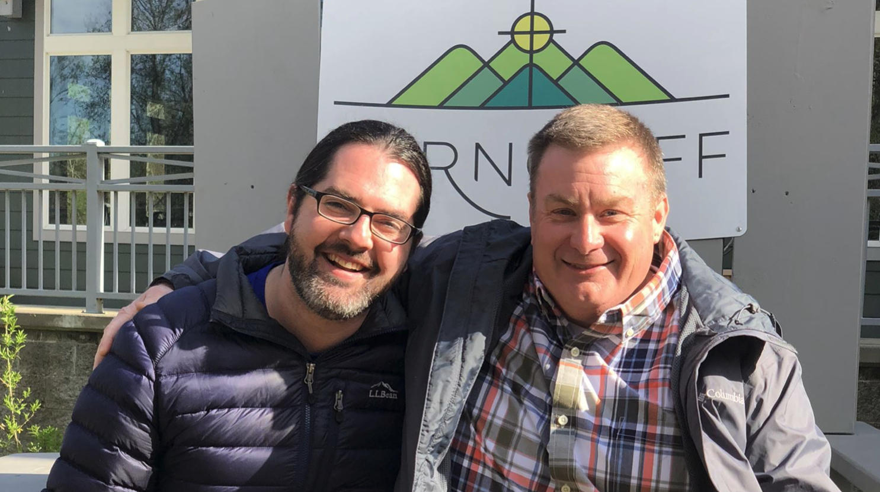
__________________________________________________________________________________________
On the screen, you’ll find a picture of me with my youth director growing up. This is the two of us a few years ago at a clergy retreat in Arkansas. His name is Rev. Dr. John Ryan and he now serves a congregation not too far from here as an Associate pastor at Davidson College Presbyterian Church. But the better part of twenty years ago, I was starting to look at colleges and I was originally looking at large, state universities like the University of Georgia because, at the time, I actually thought I wanted to be a lawyer. But as I was making my rounds, visiting different campuses, John pulled me aside one day at church and said to me,
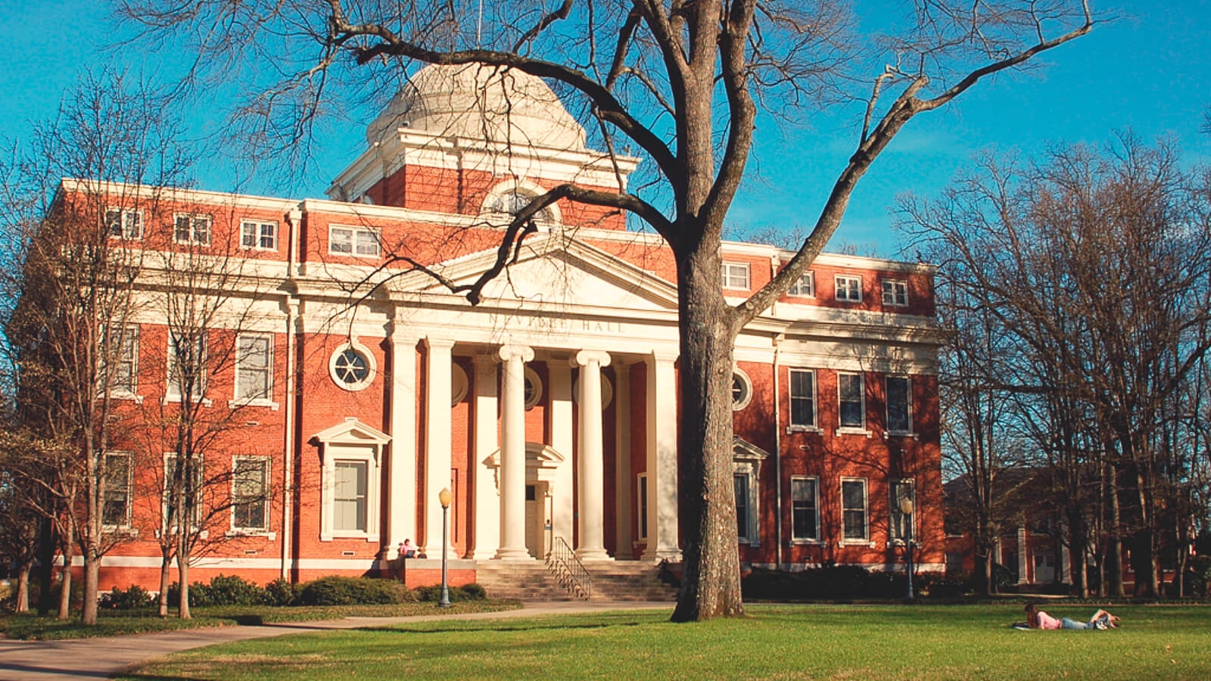
“You know, there’s a great little school in Clinton, South Carolina called Presbyterian College and you should check it out. A much different feel, of course, than a big university but it’s a great place and you could actually get a scholarship because you’re a member of a Presbyterian Church.” Now, no one in my family had ever attended PC and, in fact, I had never even heard of the place. But I decided to give them a visit because I trusted John so much.
Well, long story short, I visited Presbyterian College and fell in love immediately. It was actually the first time I ever stepped foot in South Carolina, the only state in the southeast I had never been to before applying to PC.
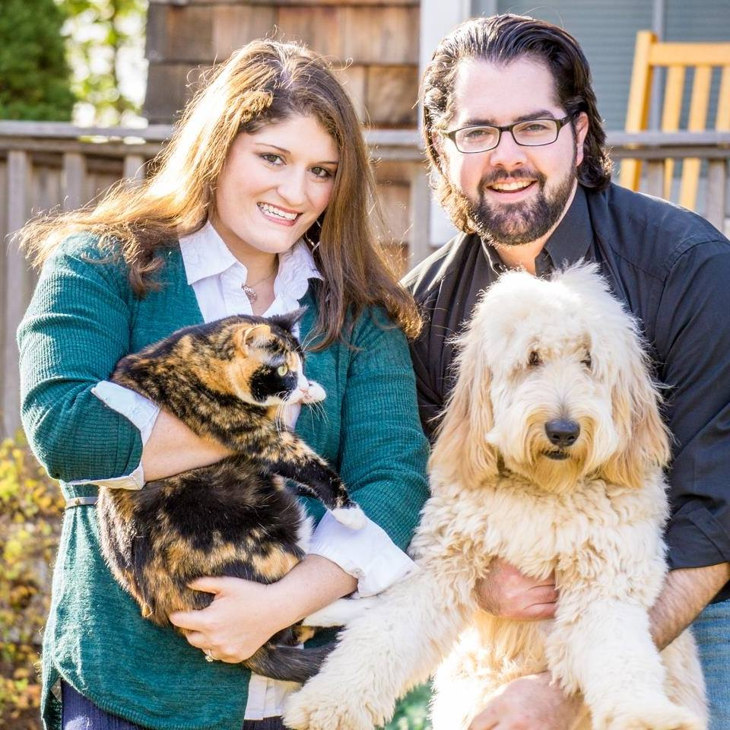
I share this with y’all for the following reason: our choices have far-reaching consequences for good or, of course, for ill. But in this case, I’m tremendously glad that John made the choice to introduce me to Presbyterian College because I’m convinced that if he hadn’t, that things would have turned out much differently!
First of all, I would never have met Tricia, as I went to PC with one of her best friends, Holly (who, for the record, I had a huge crush on but the feeling wasn’t mutual). Hazel Grace and Winnie would never have been born.

Also, if John Ryan hadn’t made the choice to introduce me to PC, I never would have met a religion professor named Peter Hobbie who helped me fall in love with the Bible all over again and led me to become a religion major.
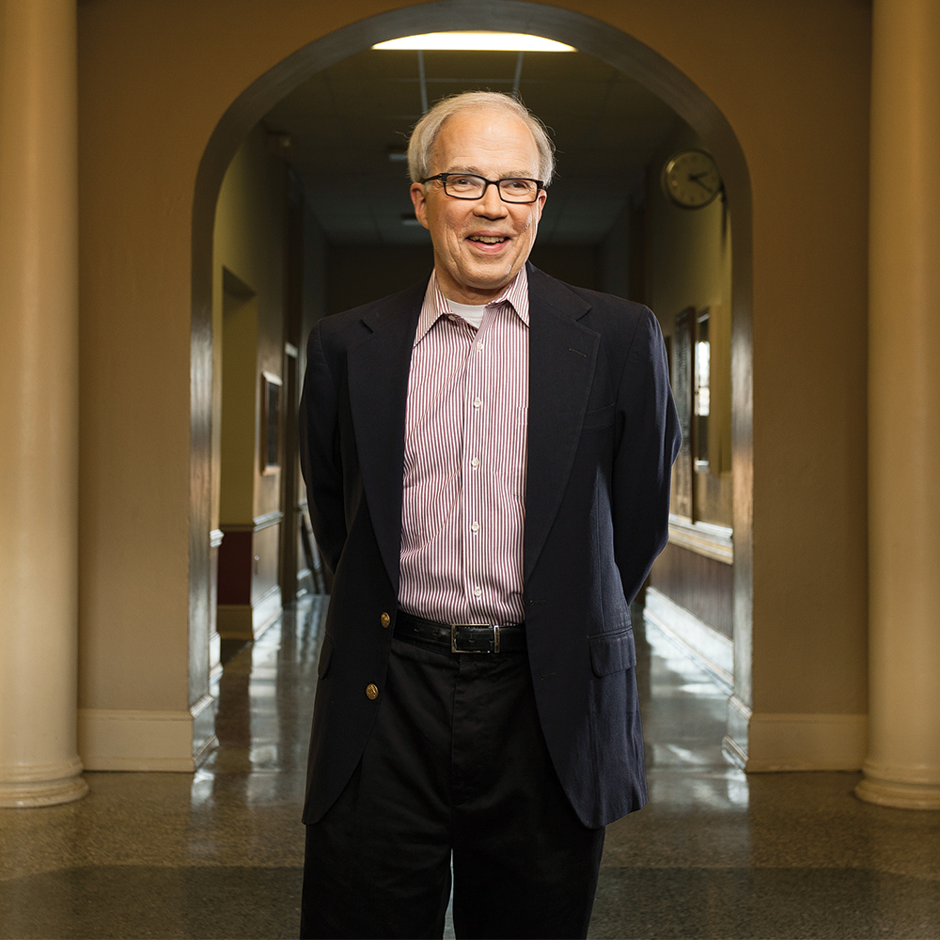
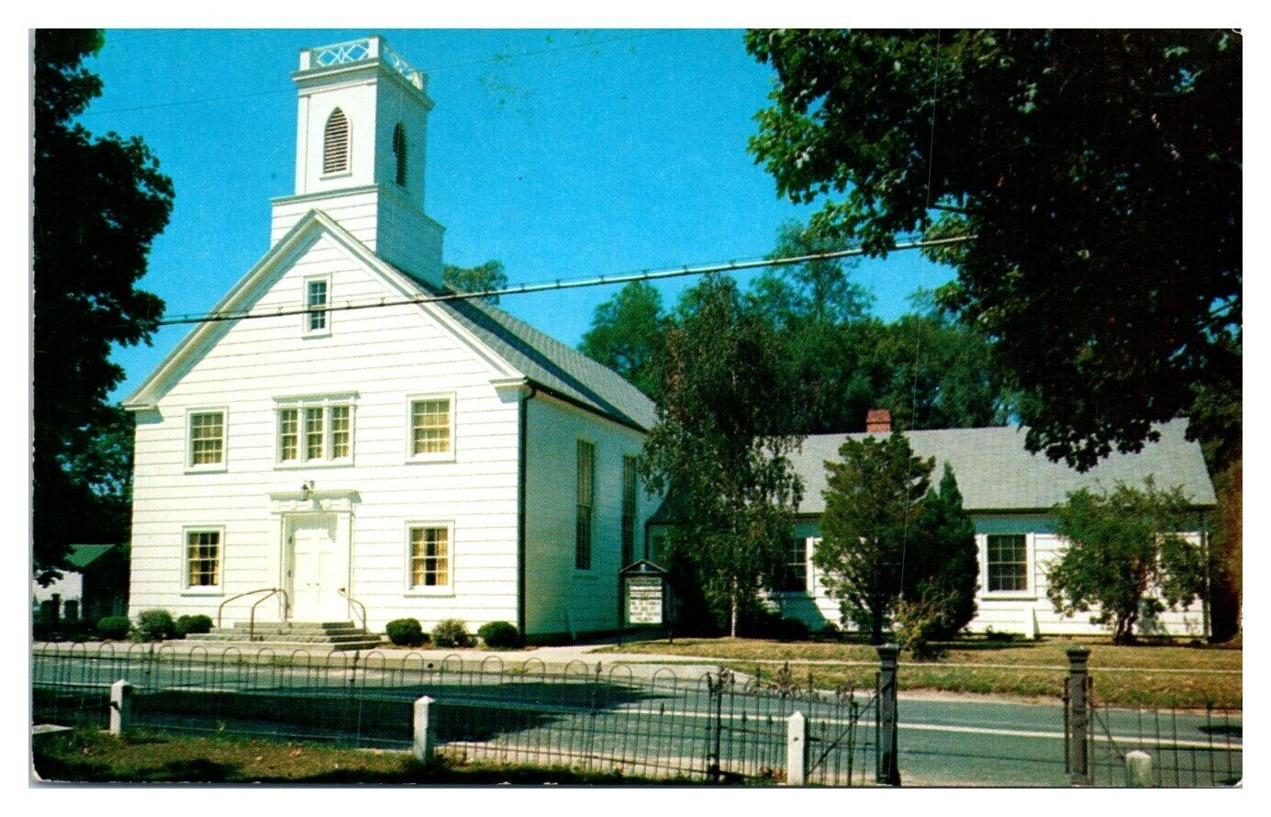
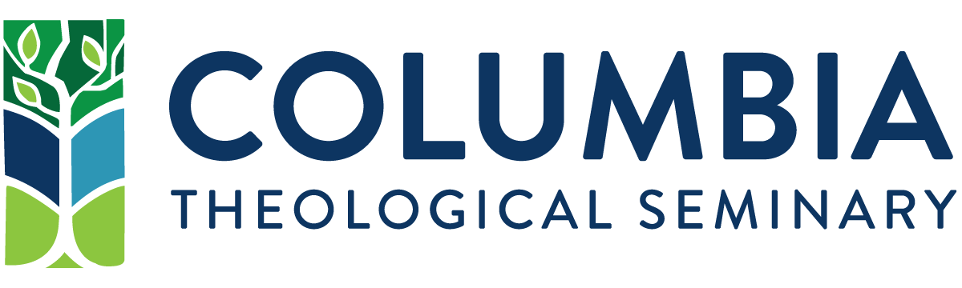
Then, I probably wouldn’t have gone to seminary in Columbia Theological Seminary in Atlanta, Georgia
or become the pastor of Shelter Island Presbyterian Church in Long Island, New York,
or become the pastor of Beaumont Presbyterian Church in Lexington, Kentucky and then, of course,

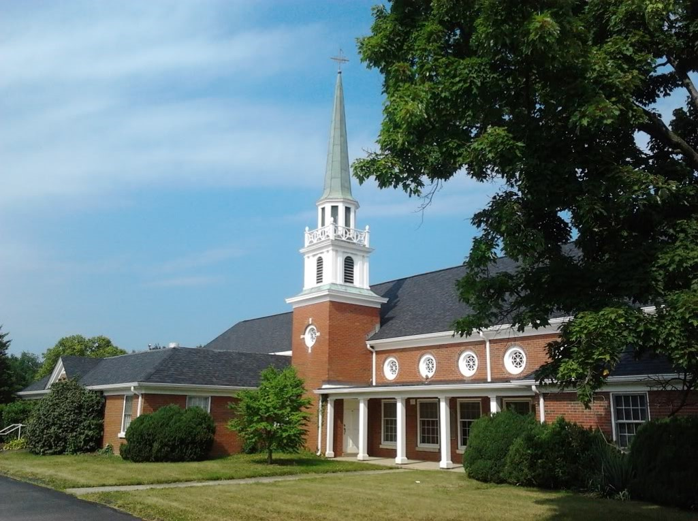
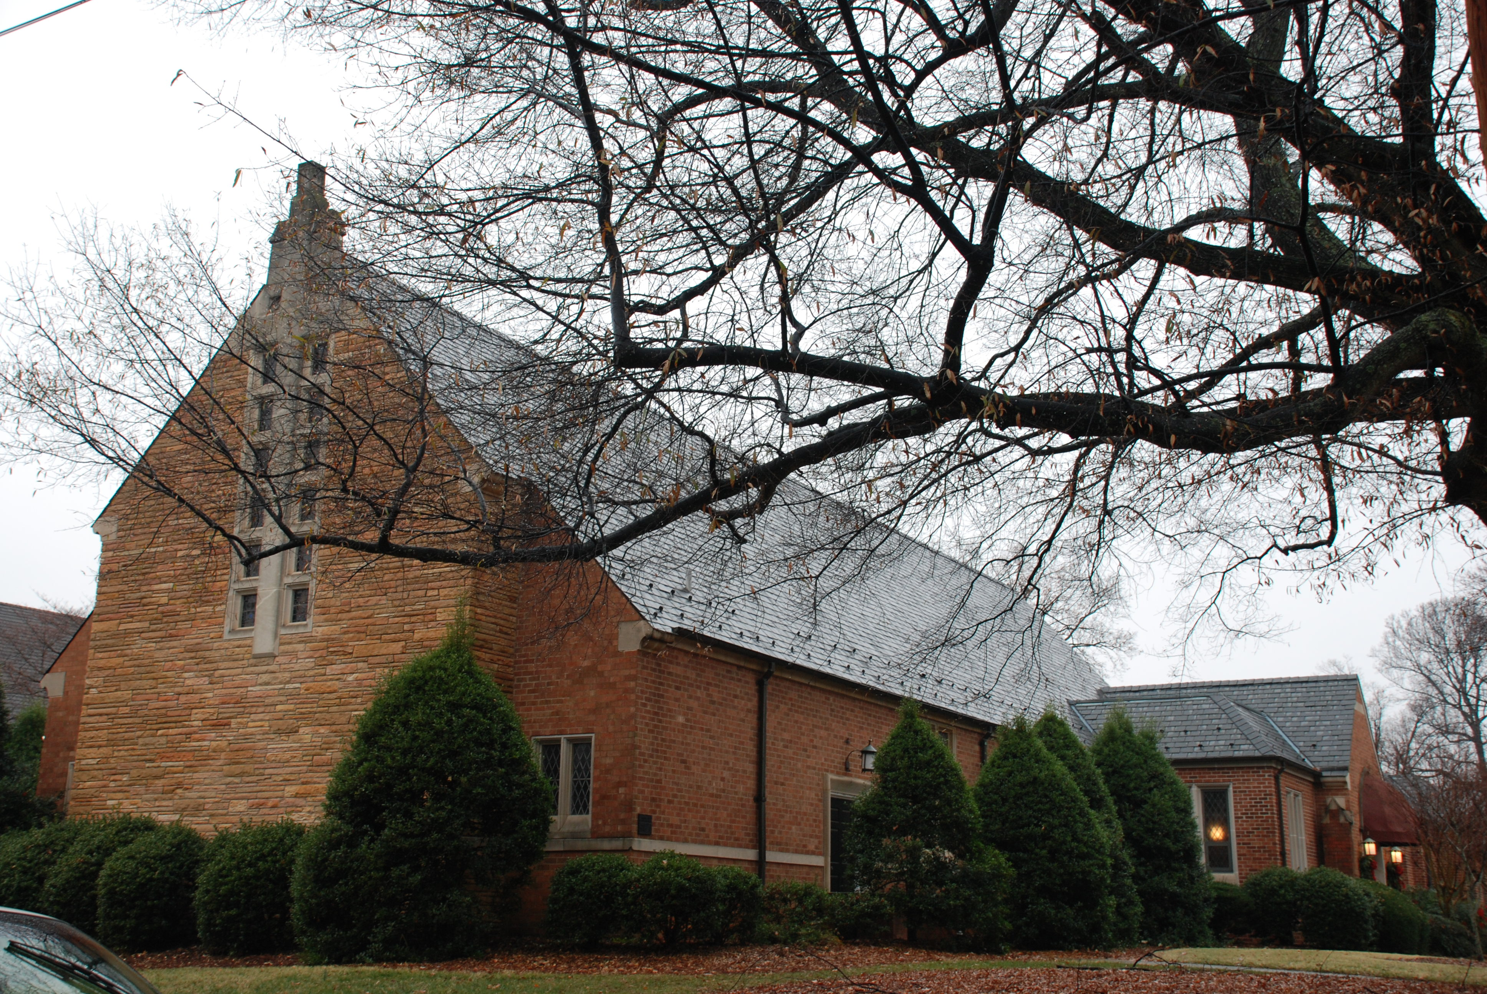
I never would have found a wonderful church in Greensboro, North Carolina called Guilford Park Presbyterian Church.
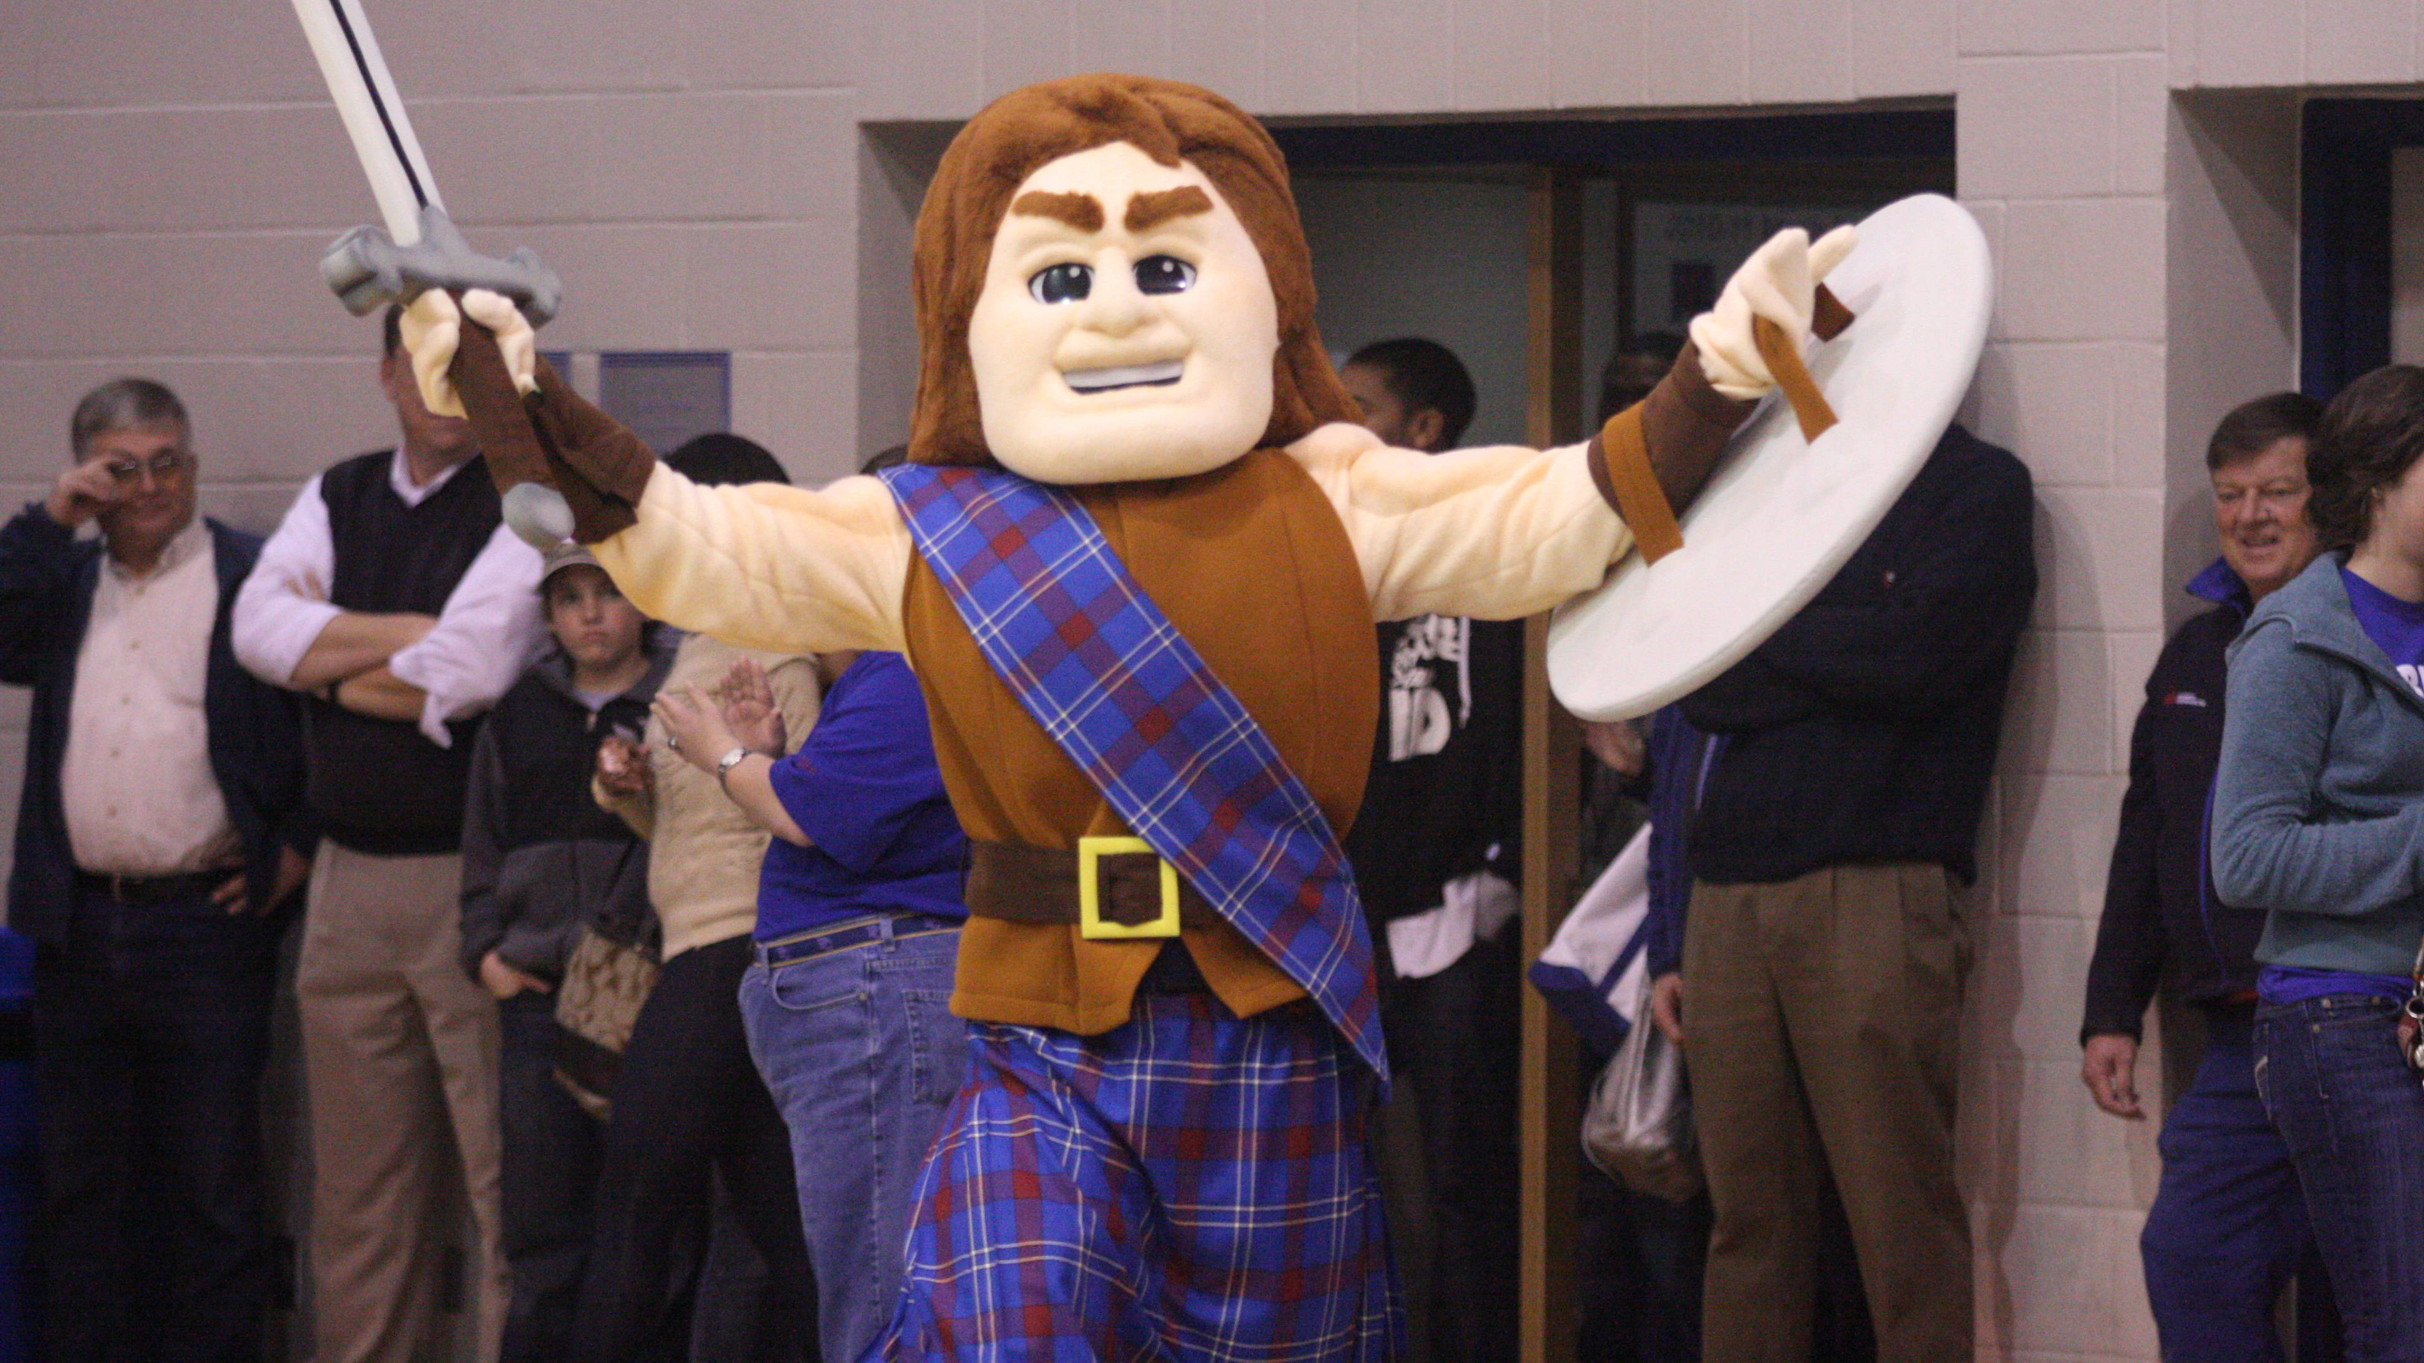
All because of a choice that was made back around the year 2005. Choices matter. As Henry David Thoreau once said so beautifully, “For it matters not how small the beginning may seem to be: what is once well done is done forever.” And here we are together this day, worshipping God on this Third Sunday in Advent, all because a youth director at First Presbyterian Church of Dalton, Georgia told me to look at a small liberal arts college in upstate South Carolina who mascot, I kid you not, is the Blue Hose.

Now, I don’t know who made the choice for that to be our mascot but sometimes we just have to live with the choices those before us have made, whether we like it or not.
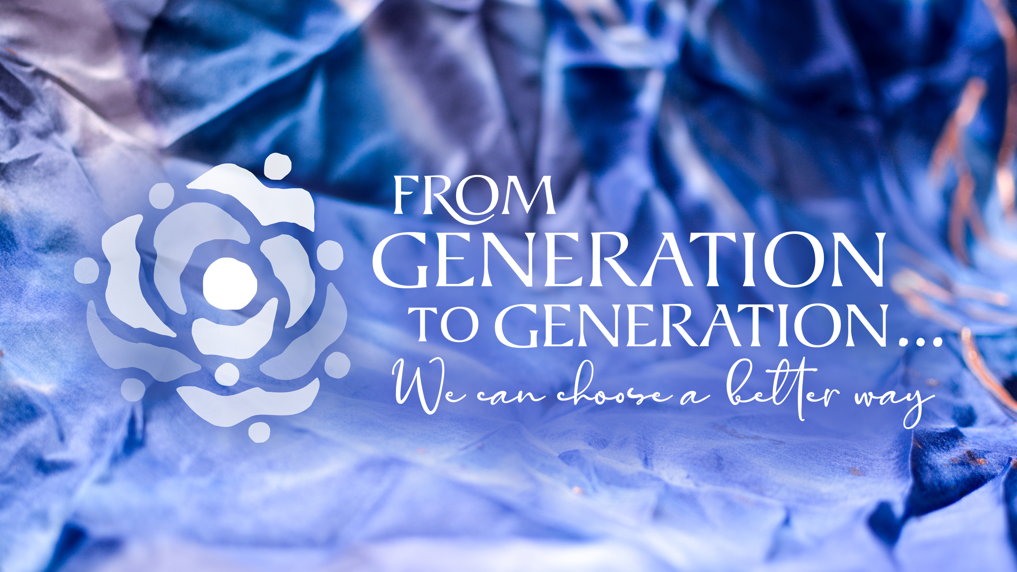
Joseph, in today’s had a choice to make that, too, would have far reaching consequences, consequences far surpassing the importance of which college I chose to attend. Last week, we journeyed with Mary’s choice to practice holy curiosity with her fear to lean into the promises of God. And this week, we look at Joseph’s choice. Of which he had two.
He could stay with Mary or he could leave her. You and I know that he chose to stay and provide for Mary and Jesus, but what if he hadn’t? What might have happened to Mary and her newborn? One might posit that God would have intervened and found another fella to take the job that Joseph turned down. But what if, and hang with me here, what if part of the vulnerability of God coming to us in the flesh was the possibility that us humans could have screwed it all up? Mary and Joseph were human, just as wondrous and flawed as any other and they could have made different choices. I think there was an inherent risk to God coming to us in the flesh. Mary could have chosen to not bear the child. Joseph could have chosen to abandon Mary and, in so doing, put both her and the newborn Jesus in very real physical danger. And this is why, I personally feel that Jesus could have died as a baby if Joseph or Mary had made different choices: because what is love without risk? Love without risk, well, just isn’t love. God came to this world. God, for reasons beyond my comprehension, chose to literally put himself in our hands in order to be with us. All because a few choices made by two people named Joseph and Mary.
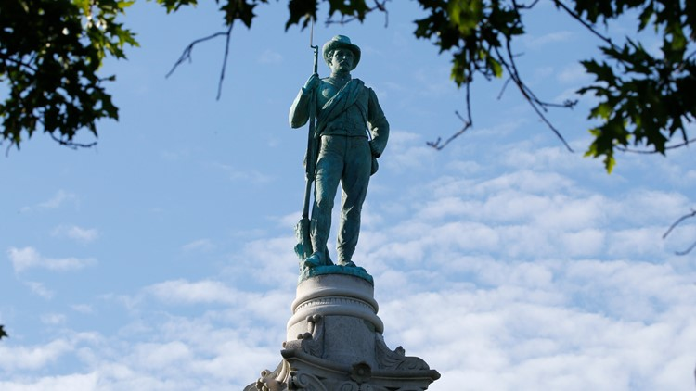
And so, I want us to think this day about choices. I want us to think about the choices we’ve inherited from the generations that have come before us. In the Word This Week last week, I gathered with several of y’all in the Westminster Room and we shared with one another choices that our ancestors have made that have hurt future generations. And before we go any further, it is important to be reminded, as I was by a member of our lectionary group this week, that all of us are shaped by the times in which we live. That being said, I learned a few weeks ago that one of my ancestors made the choice to own slaves. Another member of The Word This Week gave me permission to share with y’all that they have relatives that they know helped write the Jim Crow laws that perpetuated racial inequality in its many forms.
I spoke with another of you after the session about the heated conversation in this country about what to do with monuments of Confederate soldiers and generals. And we talked about how, on the one hand, none of us wants, or deserves, to be reduced to the sum of our mistakes by future generations and how, on the other hand, when our past generations made choices that hurt our neighbors in the present, it’s critical that we, as a society, make different choices, better choices, that build up the neighborhood instead of divide it. And there are faithful Christians that have different opinions over those choices.
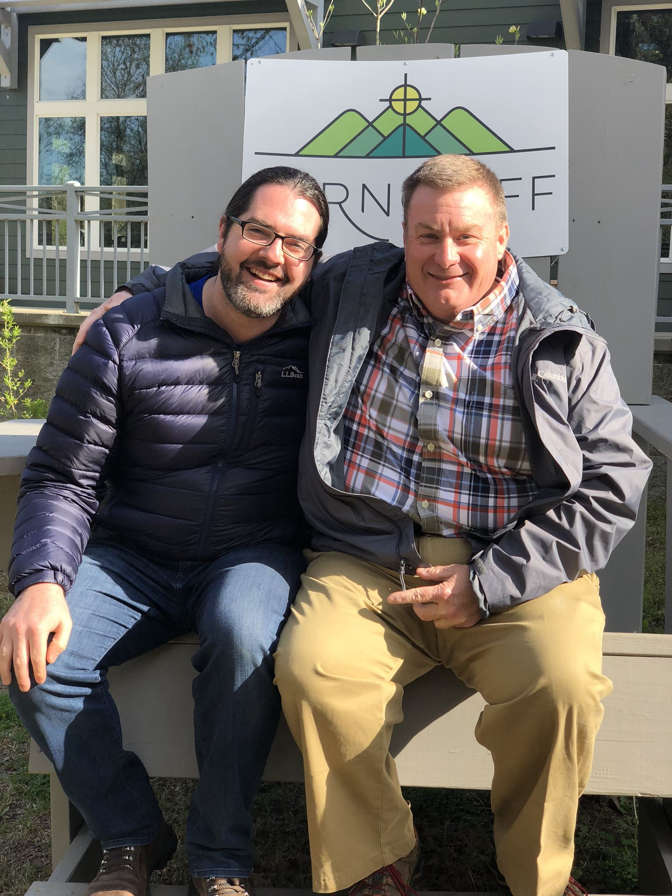
But there are also choices that are made by our ancestors that we can and should be grateful for.
I’ve already shared with you one choice that I’m grateful for, that of my old youth director introducing me to my now alma mater which led me right here to this pulpit.
I’m also grateful for the countless choices made in the past almost 75 years of this congregation that has led it to be the loving, faithful, compassionate family that it is today. And I want us, in our time, together have gratitude for the healthy choices made by past generations of this congregation while simultaneously practicing holy curiosity for how this congregation today can make choices that will bless the generations that will follow us.
In closing, I want to share with y’all two things I learned this week that I hope will give you inspiration and encouragement in the knowledge that you can always choose a better way. It’s a philosophy I was introduced to this week called “Seven Generation Thinking” and it originated with the Iroquois tribe of Native Americans that first inhabited this land. Before each and every decision was made as a tribe, the leaders would ask themselves, “Will this choice be beneficial for people of this tribe seven generations in the future?” If the answer to that question was “yes,” then they did it. If the answer was “no,” they didn’t. They have this philosophy because they had the wisdom to know that the wellbeing of their their tribe in the present was only possible because of the decisions made by their tribe seven generations in the past. That’s a truly countercultural thing in a society as fast-paced as ours with such an emphasis on immediate gratification.
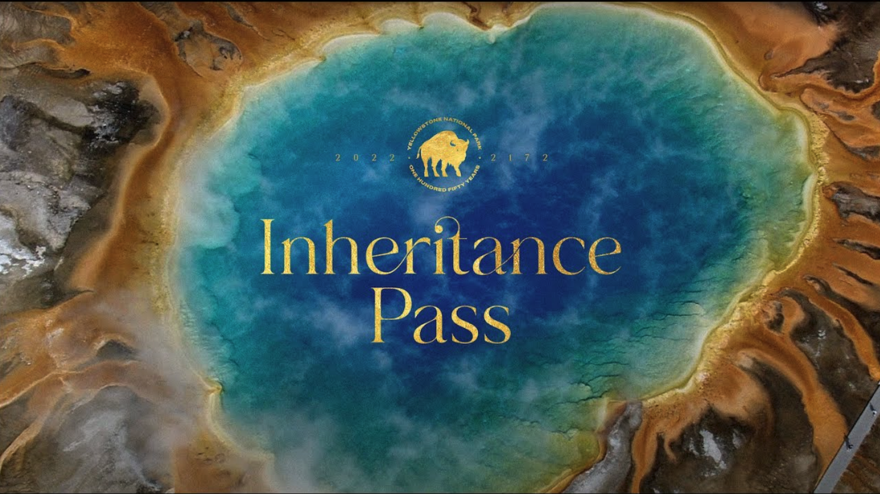
The second example I want to close with is this: I learned this week that Yellowstone National Park is celebrating its 150th anniversary and they’ve come up with a clever way to raise money for their preservation fund. Take a look at this brief video:

For $1,500 donation to the Yellowstone National Park Preservation Fund, not only does it give you a year pass starting now, but it gives you a year pass for the year 2172, 150 years from today for you to give to your child or grandkid or a friend or coworker, to pass along to their children. First of all, that’s just brilliant fundraising. Secondly, I want us to have that sort of generational wisdom and foresight. As I mentioned before, next year will mark the 75th year of Guilford Park Presbyterian Church. And I wonder, what choices will we make together - you and I - over the next years that will build up this congregation so that, in 75 years from now, that generation of disciples (in the year 2173) will be well-equipped to do whatever it is God is calling them to do then?
Now we might have different opinions about what those choices are and how their made. But I hope we can agree that we do this messy, hard, blessed work together. We do it as a family. We do it as a team. We don’t do it alone. We do it as those utterly dependent upon the presence of the Holy Spirit to guide us in this faithful work. For our choices are not made in a vacuum, their made by the Body of Christ. And those choices matter. A lot.
Joseph made a choice. He made the choice to do the hard work - with Mary - to raise that young child and set him up to be what God knew the world needed. What choices can you make that set up this congregation, your family, your neighborhood to “be the argument?” Together, you and I can - and will - choose a better way.
In the name of God the Creator, Redeemer, and Sustainer, may all of us, God’s children, say: Amen.

