__________________________________________________________________________________________________

Matthew 20:1-16
‘For the kingdom of heaven is like a landowner who went out early in the morning to hire laborers for his vineyard. After agreeing with the laborers for the usual daily wage, he sent them into his vineyard. When he went out about nine o’clock, he saw others standing idle in the market-place; and he said to them, “You also go into the vineyard, and I will pay you whatever is right.” So they went. When he went out again about noon and about three o’clock, he did the same. And about five o’clock he went out and found others standing around; and he said to them, “Why are you standing here idle all day?” They said to him, “Because no one has hired us.” He said to them, “You also go into the vineyard.” When evening came, the owner of the vineyard said to his manager, “Call the laborers and give them their pay, beginning with the last and then going to the first.” When those hired about five o’clock came, each of them received the usual daily wage. Now when the first came, they thought they would receive more; but each of them also received the usual daily wage. And when they received it, they grumbled against the landowner, saying, “These last worked only one hour, and you have made them equal to us who have borne the burden of the day and the scorching heat.” But he replied to one of them, “Friend, I am doing you no wrong; did you not agree with me for the usual daily wage? Take what belongs to you and go; I choose to give to this last the same as I give to you. Am I not allowed to do what I choose with what belongs to me? Or are you envious because I am generous?” So the last will be first, and the first will be last.’
__________________________________________________________________________________________
As I often do when preaching the lectionary, before I write my sermon I go back and see how I’ve preached the text in previous years. Given that the lectionary is a three-year cycle and I’ve been ordained just over nine years, some of these texts, like the one before us, I’ve preached on at least once or twice before. Looking back three and six years when this text last came around the lectionary, I’ve preached a version of a sermon which, I’ll freely admit, is probably a sermon many of you have heard before. I’ll summarize here:
"The landowner represents God. The landowner is the good, generous character in the story who gives just as much money to the workers who had been there only an hour as he promised to pay the other workers who had toiled in the sun the whole day. This is an analogy that reminds us to stop getting in a tizzy comparing ourselves to one another and judging others’ self worth. A faithful response to God’s generosity is to rejoice when others receive that generosity in ways that may seem unfair or even outrageous.”
Now that sermon has been preached by me and others for years and there may in fact be some important truth to be gleaned from that interpretation. However, the parables of the Gospels are intentionally difficult to pin down to one interpretation alone. Their playfulness, imagination, and absurdity invite us to multiple perspectives and, some would argue, at times, competing perspectives.
So I invite you to join me in exploring another perspective of this parable.
What if the landowner isn’t meant to represent God? What if the landowner isn’t meant to be the example of “good” and “generous” behavior?
What if the landowner is the bad guy?
Now before anyone paints me a heretic, hear me out! To understand this take on the parable we must first learn a bit of what the life of a day laborer was like in Jesus’ time.
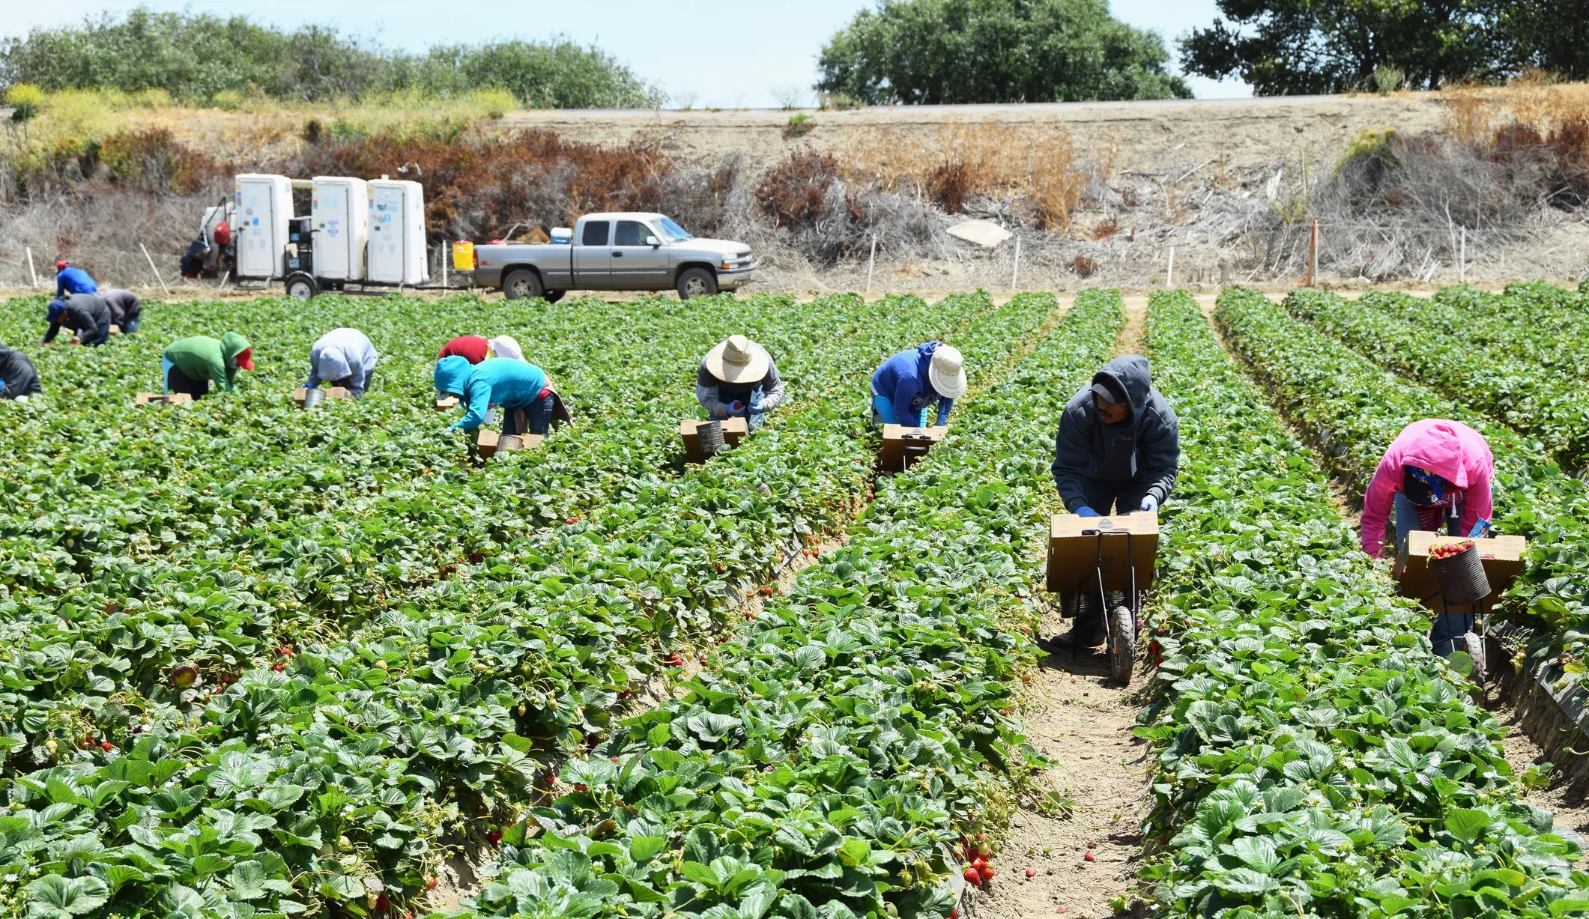
The day laborers were an extremely vulnerable class of people who existed in a ruthless economy. Actually, many would consider them lower than slaves. Day laborers constituted around 5-15% of the population. As my friend and colleague, Rev. Dr. Leah Schade puts it: “They have no property, no rights, no support system, and are at the mercy of those who hire them.” In some cases, landowners such as the one in today’s text would hire day laborers to do the most brutal, back-breaking tasks because they didn’t want to hurt their human “property,” their slaves. These day laborers still exist, by the way, all around us today, many of them undocumented immigrants. They pick the vegetables we eat. They do our landscaping.
They are the essential workers that we counted on so desperately when COVID hit. They do much of the menial labor that others don’t want to do that keeps our economy going. Such was the same of the day laborers of Jesus’ time.
And for one day of that back-breaking work, the landowner promises the day laborers one denarius.

Most biblical scholars estimate that a denarius equalled a days’ work at or near today’s minimum wage. The federal minimum wage is $7.25 an hour. If these day laborers worked full time, they would make approximately $15,000 a year (pre-tax) with no healthcare or benefits (for reference, the current poverty level for a family of four is around $30,000). For the whole days’ work, the day laborers in today’s story would have made around 65-70 bucks. All this is to simply say, what we’d be tempted to call a “fair” wage is hardly a livable one, even for the ones who only worked an hour or two.
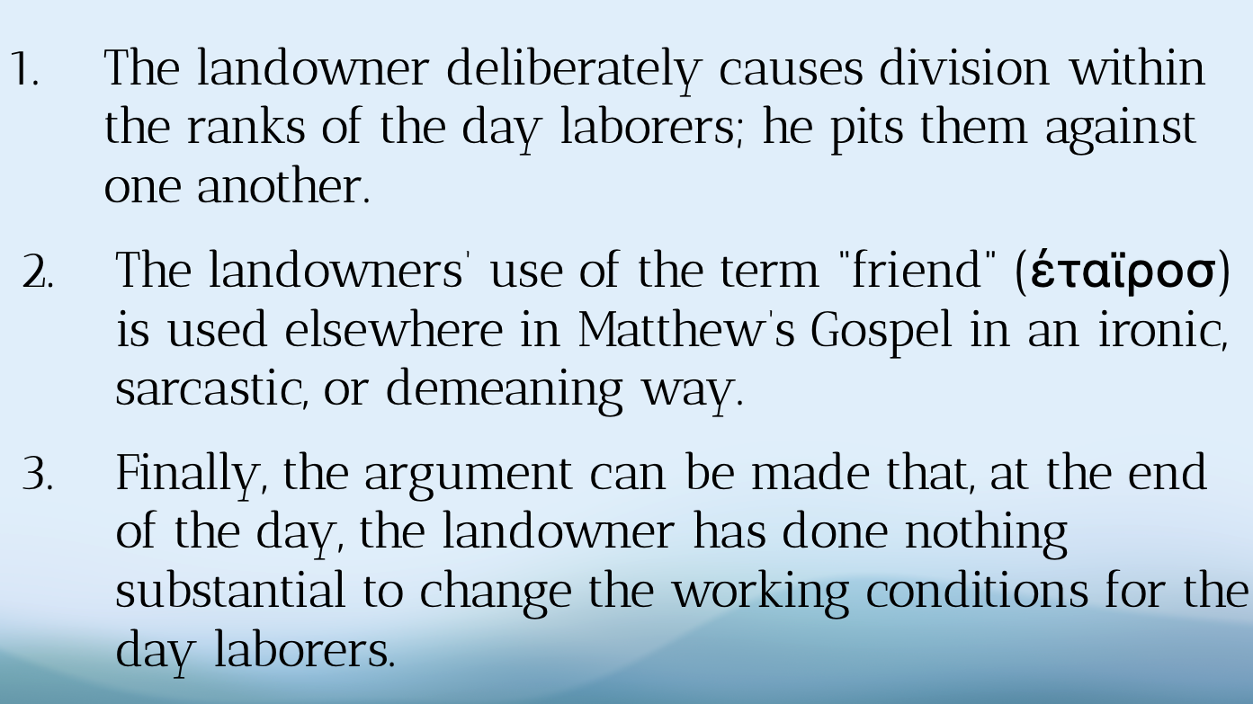
And in the context of the pitiful life of a day laborer, there are two actions and one inaction of the landowner that has led me, and others, to question the popular assumption that he is as generous as he says he is.

- The landowner deliberately causes division within the ranks of the day laborers; he pits them against one another. If the day laborers had been paid with the ones who had been there the longest first, then they likely would have taken their money and left before the others had been paid, being none the wiser as to the landowner’s unusual gesture. Instead, the landowner pays the workers who had worked the shortest to go first, knowing full well that the others who had been there all day would witness it and notice the lucky workers’ elation. Why does this matter? Because it’s a well-documented truth that the powerful benefit from low-wage workers fighting amongst themselves. At this very moment, we’re witnessing both a writers’ strike (SAG-AFTRA) and an auto workers’ strike (UAW) who are picketing in protest of the growing disparity between the salaries of the CEOs and those of the average worker.
- The landowners’ use of the term “friend” is used elsewhere in Matthew’s Gospel in an ironic, sarcastic, or demeaning way. In verse 13, when addressing the disgruntled day laborer, the landowner calls him “friend.” But if we look at the other times that Matthew uses that same word in the Gospel, it calls into question the sincerity of its tone. For example, in Matthew 22 the king in another parable calls “friend" someone he’s about to have “bound hand and foot and booted into the outer darkness.” Additionally, in Matthew 26, Jesus calls Judas “friend” as he betrays him in the Garden of Gethsemane. If this landowner is truly as generous as he says he is, why is possibly speaking to his workers in a demeaning fashion?
- Finally, the argument can be made that, at the end of the day, the landowner has done nothing substantial to change the working conditions for the day laborers. Ostensibly, they will wake the next morning to the same economic circumstances that keep them living paycheck to paycheck. In other words, the landowner is treating the symptoms of the economic disease by giving lip-service to generosity without actually changing the system that has allowed him to get rich off the backs of his workers.
Now, you get to decide for yourself whether these observations are convincing enough to call the “generosity” of the landowner into question. That’s the beautiful - and challenging - thing about parables: one person can read them and interpret them one way and another person can read them and interpret them in a completely different fashion. Just because one person sees it one way doesn’t mean that the other’s way is unfaithful or “un-Christian.” At their best, our interpretations of the parables drive us deeper; they help us ask the “what if” questions that deepen our faith expand our moral imaginations.
For example, what if the day laborers refused to allow the landowner’s unorthodox behavior to divide them? What if they remained unified and unionized themselves to advocate for themselves?
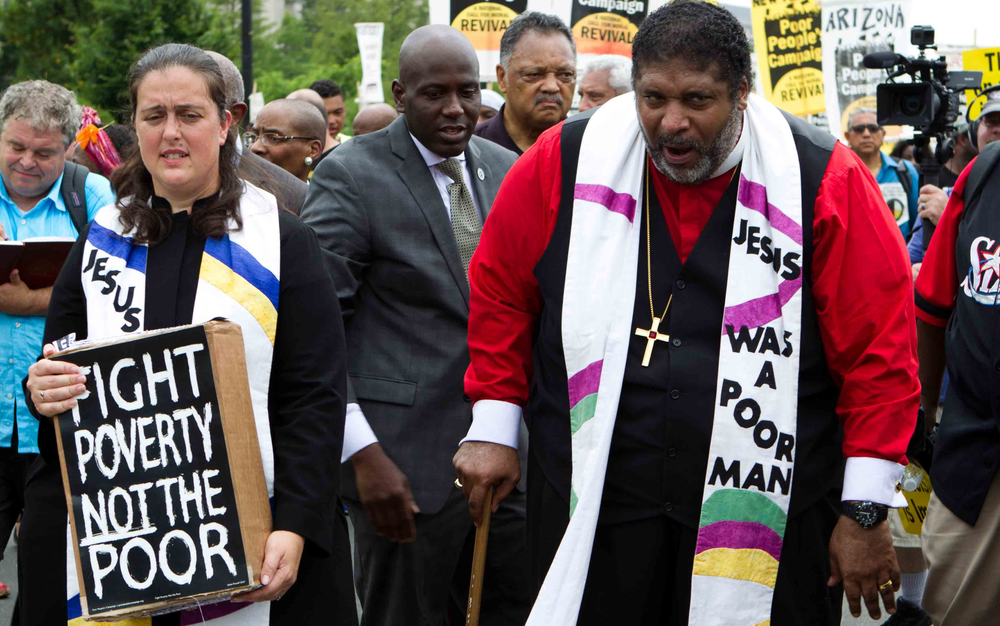
What if the landowner really wanted to shake things up and turned the land into a co-op, offering the day laborers the opportunity to share ownership of the land?
What if the landowner, or the Church for that matter, used that influence to bring awareness to the harsh working conditions of day laborers and advocated on their behalf in preaching, policy, and increased public consciousness? What if there was no need for day laborers because those people had access to jobs that included healthcare, vacation, family leave time, and pensions to support their families?
What is a fair wage? What does fair even mean in God’s economy? Whether you think the landowner represents God or whether you believe his behavior to be problematic, I hope we all agree that this parable is incredibly complex and, as such, our interpretations of it will be equally complex. Like it or not, I think Jesus made these parables intentionally complex because then it forces us to do what we’re doing right now: wrestling with the text. Expanding our moral imagination. Seeing things from different points of view.
So, is the landowner God? Is the landowner not God? At the end of the day, I think both possibilities can reveal truths about the Kingdom of Heaven; a place - here and now - where we have these conversations about what is fair. And as we struggle with what it means to provide a “fair” wage for everyone, may we keep our eyes on the humanity of those - like the day laborers - who are among the most vulnerable in the neighborhood.
In the name of God the Creator, Redeemer, and Sustainer, may all of us, God’s children, say: Amen.

https://www.patheos.com/blogs/ecopreacher/2023/09/workers-in-the-vineyard-economy-of-exploitation-matthew-20/
https://www.workingpreacher.org/commentaries/revised-common-lectionary/ordinary-25/commentary-on-matthew-201-16

