_____________________________________________________________________________
Psalm 98
O sing to the Lord a new song,
for he has done marvelous things.
His right hand and his holy arm
have gained him victory.
The Lord has made known his victory;
he has revealed his vindication in the sight of the nations.
He has remembered his steadfast love and faithfulness
to the house of Israel.
All the ends of the earth have seen
the victory of our God.
Make a joyful noise to the Lord, all the earth;
break forth into joyous song and sing praises.
Sing praises to the Lord with the lyre,
with the lyre and the sound of melody.
With trumpets and the sound of the horn
make a joyful noise before the King, the Lord.
Let the sea roar, and all that fills it;
the world and those who live in it.
Let the floods clap their hands;
let the hills sing together for joy
at the presence of the Lord, for he is coming
to judge the earth.
He will judge the world with righteousness,
and the peoples with equity.
_____________________________________________________________________________
This is Church Curmudgeon. Church Curmudgeon does not like change. Church Curmudgeon gives this perfectly-practiced death-stare to anyone who dares sit in his pew. Church Curmudgeon loves the Church and is especially fond for the way things used to be and does pretty much everything in his power to restore the church to its former greatness. Church Curmudgeon is a dedicated worker and you can ask him to do pretty much anything, as long as that ask doesn’t involve singing a new hymn.
Why would we need to, anyways? We have plenty of good hymns already. Good reformed, well-known, predictable, singable hymns. Why on earth would we purchase that new hymnal or sing that new song? Church Curmudgeon, after all, lives in a very chaotic, unpredictable, and increasingly pluralistic world. The Church seems like the one place where he can go and not be surprised. The Church is a sanctuary for him, a place for him to escape the rest of the world where he can’t keep up with all the change. So please, don’t ask Church Curmudgeon to sing a new hymn, not unless you want to see that steely-eyed expression glaring at you from the pew in front of you.
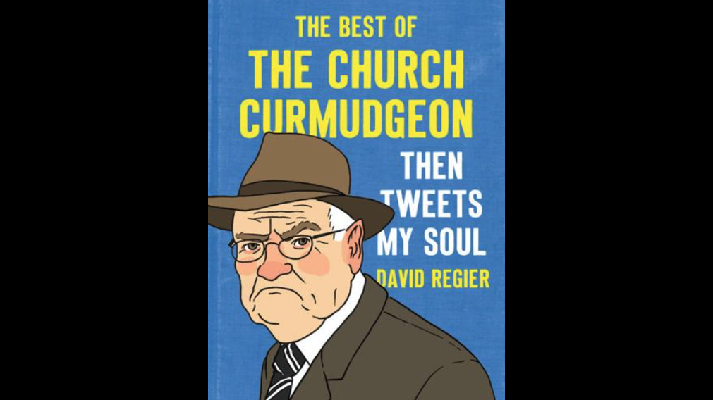
Neighbors, Church Curmudgeon happens to be a parody account on Twitter, or “X” as I’m told it’s called these days. He gifts us with social commentary with various posts complaining about the church changing the color of the carpet, or the introduction of the profane use of guitar in worship, or remarking at the audacity of changing the bulletin font from Times New Roman to Goudy Old Style.
If you want to learn more of Church Curmudgeon’s ways, you can check it out in his new best-selling book, “Then Tweets My Soul.”
Yes, Church Curmudgeon is a parody account on twitter. But he’s more than that. For those of us who have been doing this thing called “Church” for long enough, there’s at least a little bit of Church Curmudgeon in each of us.
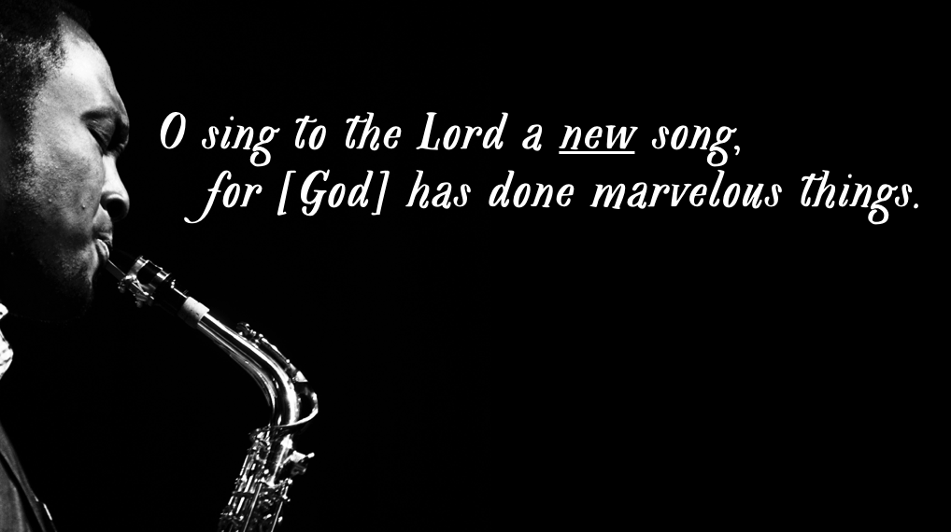
Which is why we need Psalm 98 to challenge that pithy, grumpy voice inside us all that despises change.
O sing to the Lord a new song, for [God] has done marvelous things.
A little more than a decade ago, our denomination developed a new hymnal, an update from its predecessor, the 1990 “Blue” hymnal. I was in seminary at the time and I remember the promotional tour the committee who put the hymnal together did to introduce the Church to our newest song book. I’ll never forget once when Mel Bringle, who some of y’all know, was asked the following question: “Why do we need new hymns?” Her response was perfect: “Because God never stops doing new things.”
My colleague was echoing the theology of Psalm 98, a song both ancient and new that reminds us that new songs are called for! No, it doesn’t mean we toss Amazing Grace, Come Thou Fount, and Great Is Thy Faithfulness into the trash bin. It simply means that since our understanding of God’s movement and presence in the world is ever expanding, so too should our canon of music with which we lift praise and prayer.
Now, admittedly, I am not an unbiased messenger of this truth. I’m a hymn writer. Obviously, I’m in favor of singing new songs. But Psalm 98 connects me, and you, and the Church to a long, storied history of making joyful noise in praise to the Author of all Creation. And Psalm 98 reminds us that us humans do not, in fact, have a monopoly on that joyful noise. Quite to the contrary, we are but one voice in a symphony of song sung by all inhabitants of that creation.
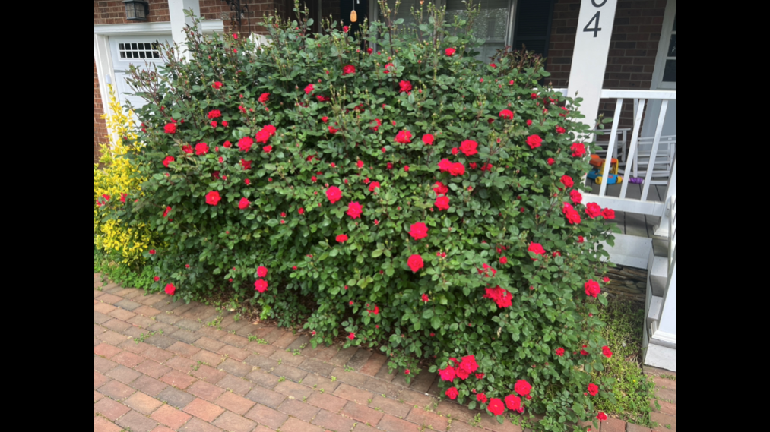
After its opening line with its strong imperative to sing new songs, Psalm 98 establishes the totality of God’s reign, a reign that encompasses ALL of creation. And since that reign encompasses ALL of creation, that song can’t simply be sung by humans. If we look closely we see creation’s song of praise everywhere we look.
This is the rosebush in front of our home. Every day, when I think it’s grown to its fullest and most glorious extent, it surprises me. It keeps getting bigger, and brighter, and bolder each day. I know understand why they call this particular plant “Knock Out” roses. This is a new song of creation.
Introduce Hymn

